KAMPUR COLLEGE, KAMPUR
NAGAON, ASSAM
Accredited by NAAC with ‘B’ Grade (2nd Cycle)

2.6.1.: PROGRAMME SPECIFIC OUTCOMES AND COURSE

SPECIFIC OUTCOMES

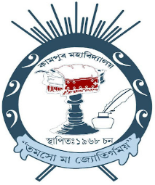

FOR THE ACADEMIC YEAR
2023-2024

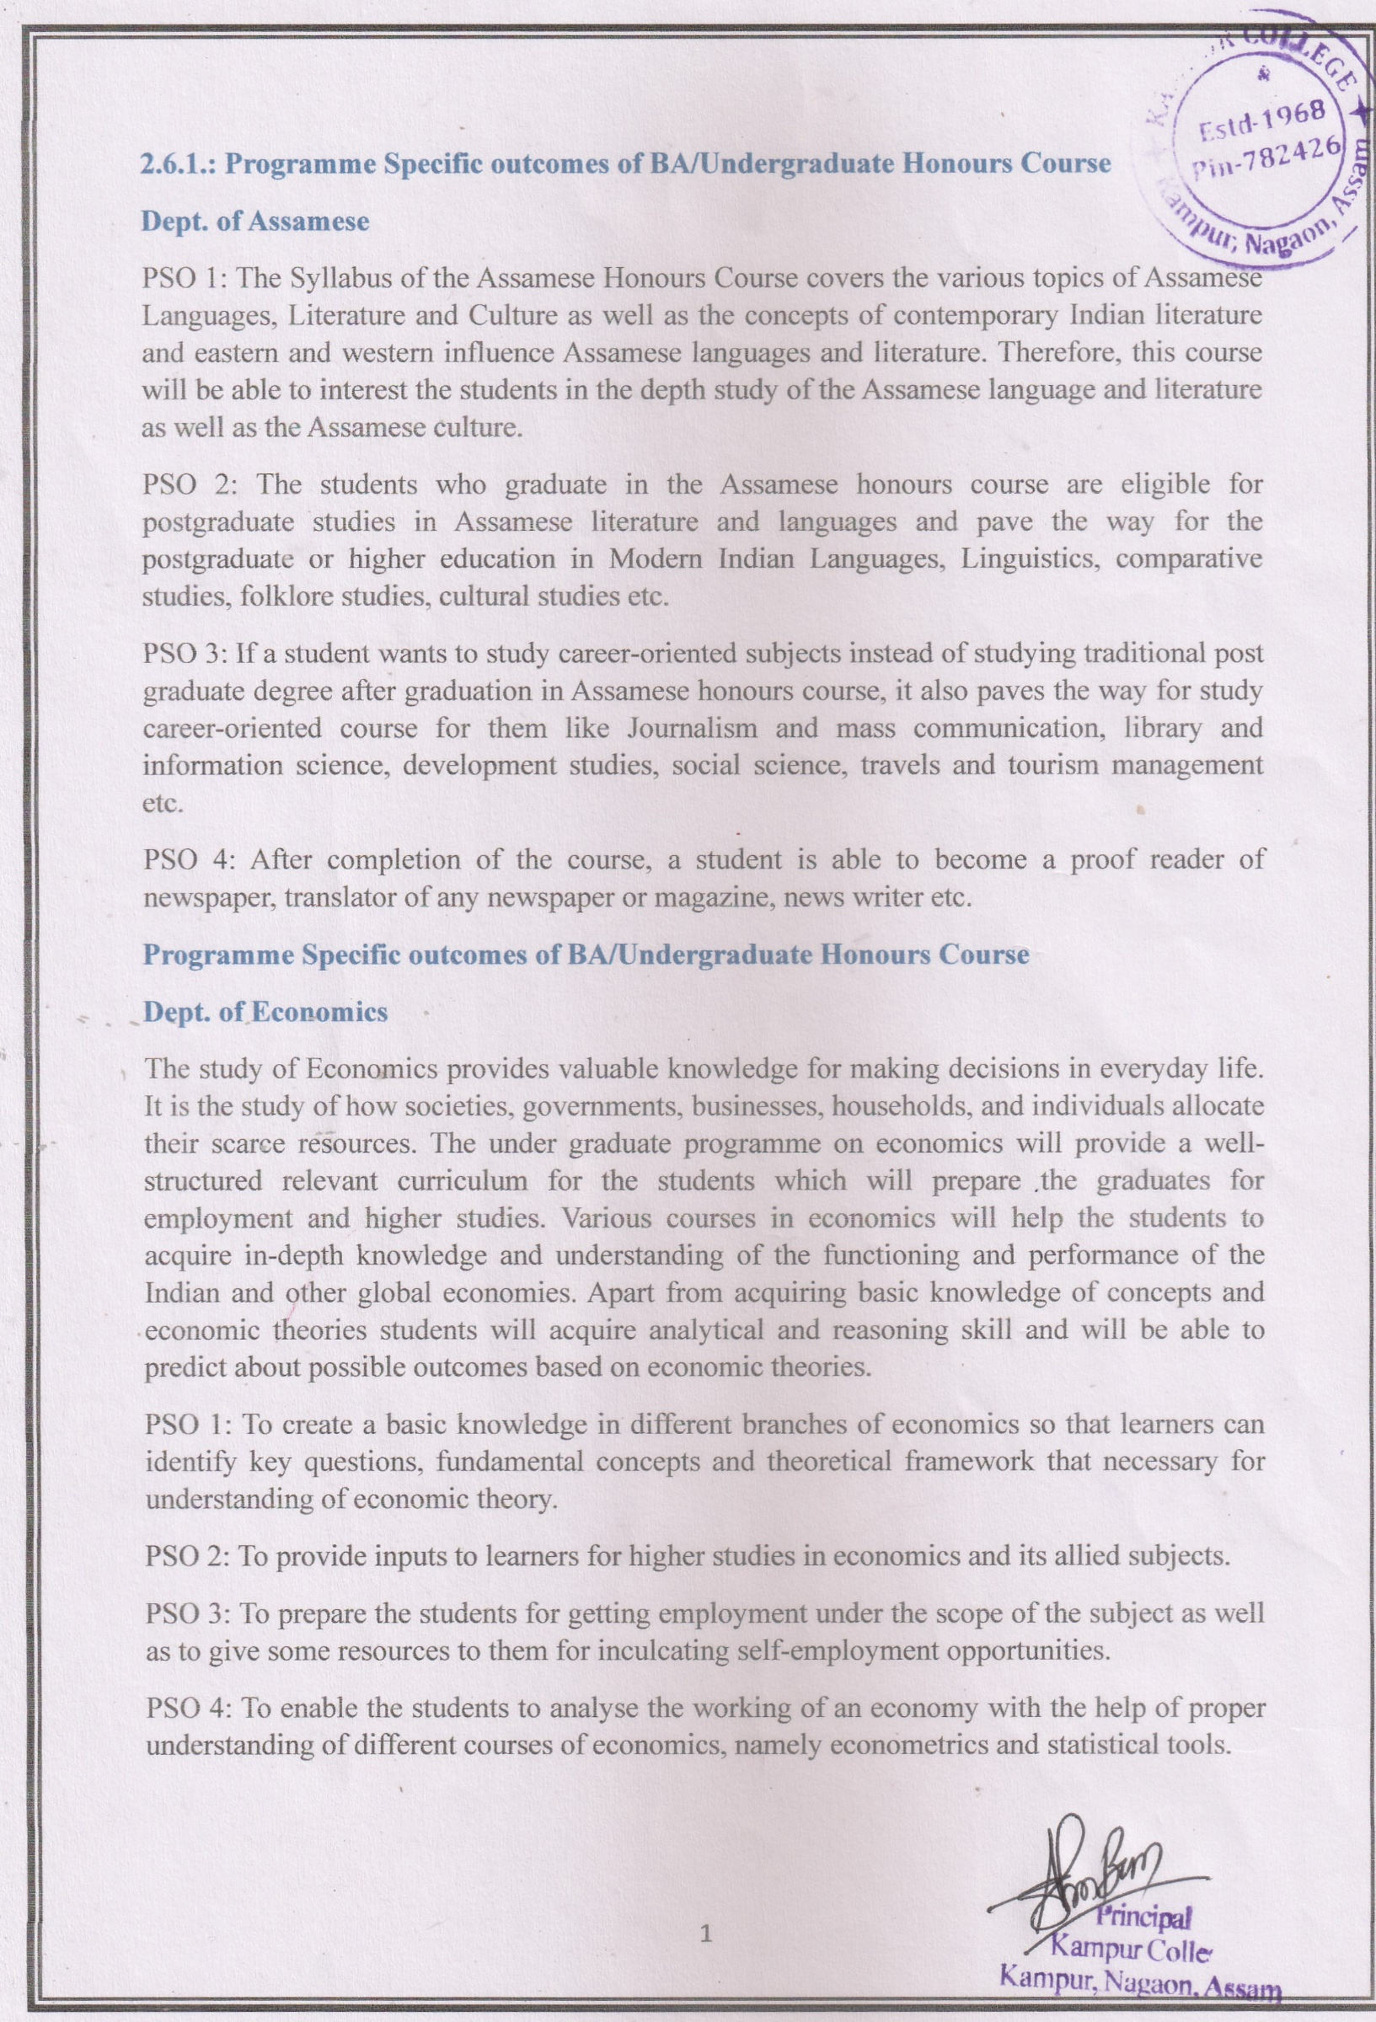

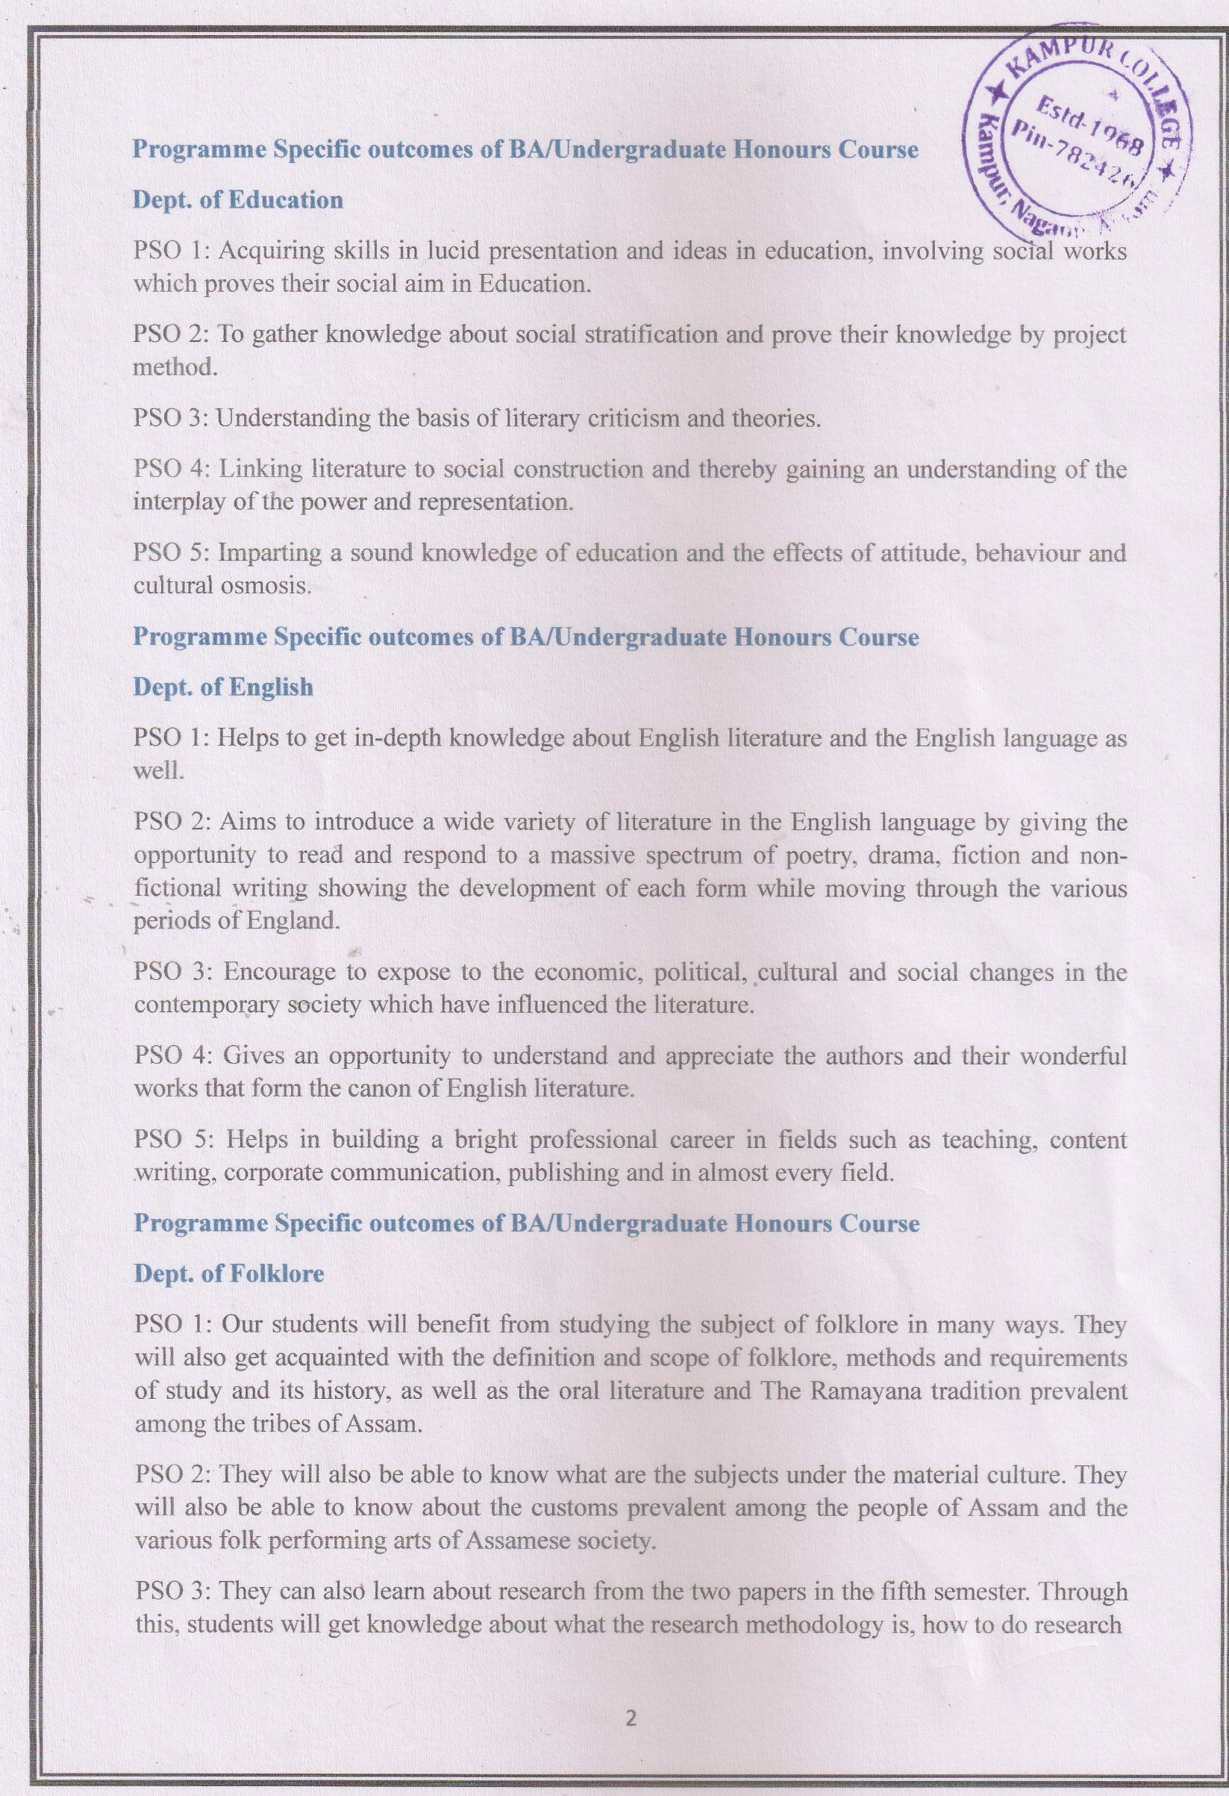

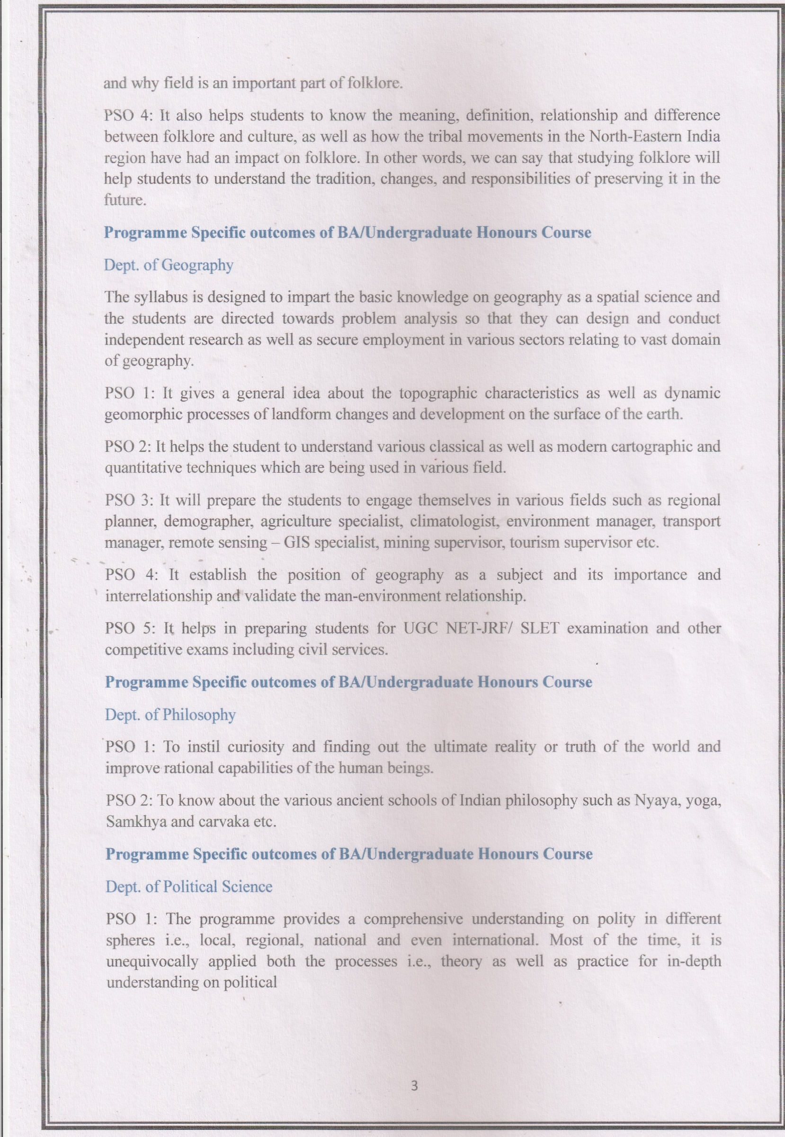

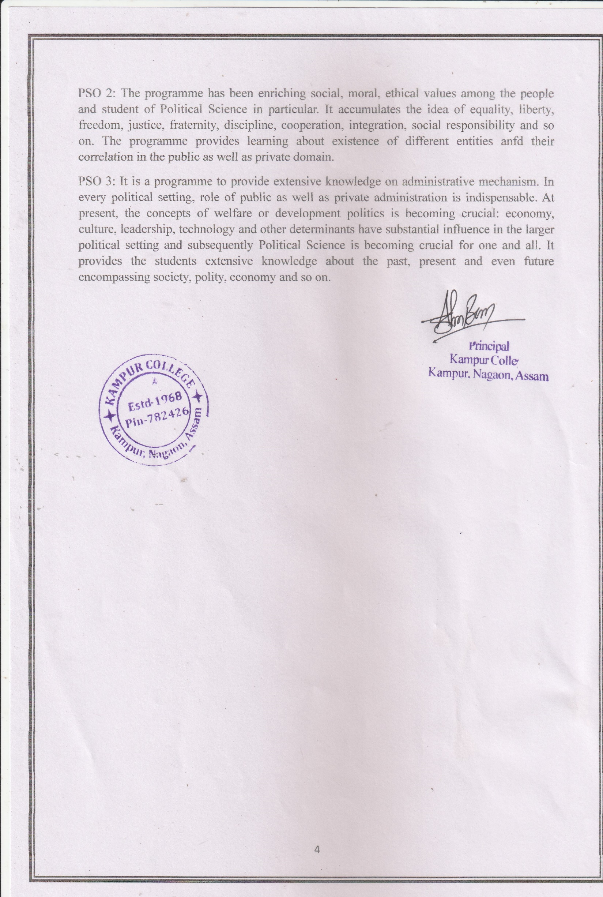
COURSE OUTCOME (CBCS & FYUGP COURSE)
OUTCOME OF COURSES UNDER BA MAJOR PROGRAMME IN ASSAMESE
FYUGP:
1ST SEMESTER:
PAPER: ASM0100104: ASAMIYA BHASA ARU SAHITYAR ITIHASH UPTO 1826
- To introduce students about the evolution and development of Assamese literature and language from the beginning up to 1826.
2ND SEMESTER:
PAPER: ASM0200104: ASAMIYA BHASA ARU SAHITYAR ITIHASH FROM 1826 TO 2000
- To introduce students about the evolution and development of Assamese literature and language from 1826 to 2000.
- It also helps to know about the Romantic and Modern Assamese literature and language of colonial Assam.
CBCS:
Paper 3016 Entering Assamese Literature
This paper is a collection of some Assamese creative and critical writings. This paper helps the students to introduce the creative and critical writings of Assamese literature.
ASM-HC- 3026: ASSAMESE POETRY
This text will introduce students to Pre-Sankari, Sankari, Romance and Modern Poetry.
ASM-HC- 3036: CULTURE OF ASSAM
Knowledge of Assamese Culture, Folklore, Religious Traditions, Festivals, Environmental Arts, Architecture, Sculpture and Painting.
ASM-HC- 4016 COMPARATIVE INDIAN LITERATURE
This paper will introduce the students to the background and introduction of comparative literature as well as modern Indian literature.

ASM-HC- 4026 ASSAMESE LANGUAGE COMBINATION: ARYAN LANGUAGE AND NON-ARYAN LANGUAGE
This text will help to determine the relationship of Assamese Language with Sanskrit, Prakrit, Bengali, Oriya and other Aryan Languages. Also to discuss the effects and elements of different Aryan Languages like Assyrian Language like Tai-Ahom, Boro, Rava, Khachi etc.
ASM-HC- 4036 ASSAMESE PROSE LITERATURE (FROM THE BEGINNING TO THE EIGHTEENTH CENTURY)
This paper creates a clear idea in the minds of students about the Assamese prose literature from the prose of Sankardev’s plays to the prose of Assamese history.
ASM-HC-5016 ASSMESE DRAMA AND PRESENTATION STYLE
This paper will provide students with an outline of the history of Assamese drama as well as representative drama. It will also learn about the performance style of the special drama forms of Assam.
ASM-HC-5026 ASSAMESE GRAMMAR
This paper attempts to make the students familiar with the history of Assamese Grammar, classification, elements of grammar, phonetic and phonemic scripts. It also attempts to give the use of Assamese morphology.
ASM-HE-5016 STUDY OF ASSAMESE FOLK LITERATURE
This paper will introduce students to the nature of folk literature and various resources of Assamese folk literature.
ASM-HE-5036 SANKARDEVA
This paper tries to teach students about the bargit, kirtan ghosa, poetry and drama of Sankardev, the pioneer of Assamese literature.
ASM-HC-6016 ASSAMESE SHORT STORIES AND NOVEL
This paper creates a clear idea in the minds of students about the Assamese short story and Assamese Novel and encouraging students in creativity related to Assamese short story and novels.
ASM-HC-6026 HISTORY OF ASSAMESE SCRIPT
This paper attempts to make the students familiar with the history of Assamese script, rock inscription, bronze inscription etc. By studying this the students will able to gain the basic knowledge on the Assamese script.
ASM-HE-6046 DIALECTICAL LANGUAGES OF THE ASSAMESE LANGUAGES
This paper acquaints the students with the dialectical languages of the Assamese Languages within the geographical boundary of Assam. Also, the students learn about the use of language in ancient Assamese literature.

ASM-HE-6056 PROJECT WORK
Under this course the Assamese major students are given projects on diverse topics like rituals and festivals of various tribes & caste, folk literature, performing arts, folk languages, heritage places of Assam etc. Through this project the students develop lots of knowledge and experience which will help them in further studies.
PAPER: E-308 ASSAMESE DRAMA
It impacts knowledge about trends in Assmaese Drama with special emphasis on Sankardev, Durga Prasad Majlinda Baruah, Mohendra barthakur and Ali Haidor.
PAPER: E-408 ASSMAESE SHORT STORY, NOVEL AND ESSAY
In this paper students will learn about the trends in Assamese Short story and Assamese Novel and also, they learn how to write an essay.
ASM-RG-5036 SANKARDEVA
This paper tries to teach students about the bargit, kirtan ghosa, poetry and drama of Sankardev the pioneer of Assamese literature.
ASM-RE-5036 SANKARDEVA
This paper tries to teach students about the bargit, kirtan ghosa, poetry and drama of Sankardev the pioneer of Assamese literature.
Paper: ASM-SE-5014
This course will attempt to provide theoretical and practical knowledge of poetry recitation.
PAPER: ASM-RE-6016 RHETORIC & PROSODY
This paper gives the students opportunity to learn and use Assamese rhetoric and prosody.
PAPER: ASM-RG-6016 RHETORIC & PROSODY
This paper gives the students opportunity to learn and use Assamese rhetoric and prosody.
PAPER: ASM-SE-6014
This course contains knowledge of the neatness and technique of Assamese prefixes, knowledge of correct spelling is essential for professional use of the Assamese language.

OUTCOME OF COURSES UNDER BA MAJOR PROGRAMME IN ECONOMICS:
FYUGP:
1ST SEMESTER
ECO 0100104: INTRODUCTORY ECONOMICS
After completion of this course students are exposed to the basic principles of micro economic theory. The course will illustrate how the concepts of microeconomic, macro- economics and public finance can be applied to analyses real-life situation.
2ND SEMESTER
ECO 0200104: BASIC ELEMENTS OF ECONOMICS
The outcome of this paper is to make the students able to learn the basics of DATA collection. It will help the students to learn basic feature of Indian economy, trend of national and per capita income, sector wise composition of GDP and basic demographic features such as age, density, urbanization, unemployment etc.
CBCS:
3RD SEMESTER
ECO-HC-3016: INTERMEDIATE MICROECONOMICS-1
This course is designed to provide a sound knowledge in microeconomic theory and in this course mathematical tools are used to facilitate understanding of the basic concepts. This course looks at the behaviour of the consumer and the producer and also the behaviour of a competitive firm.
ECO-HC-3026: INTERMEDIATE MACROECONOMICS-1
After studying this paper students will learn various alternative theories of output and employment determination in a closed economy in the short run as well as medium run , and the role of policy in this context. It also introduces the students to various theoretical issues related to an open economy.
ECO-HC-3036: STATISTICAL METHODS FOR ECONOMICS
This course helps the students to know the basic concepts and terminology that are fundamental to statistical analysis and inference. Concepts like probability, probability distribution of discrete and continuous random variables, sampling techniques used to collect survey data. This course also includes some topics in statistical inference such as point and interval estimation.
4TH SEMESTER
ECO-HC-4016: INTERMEDIATE MICROECONOMICS-II
This course will provide students the conceptual clarity to use mathematical tools and reasoning in microeconomics. It covers general equilibrium and welfare, imperfect markets and topics under information economics.
ECO-HC-4026: INTERMEDIATE MACROECONOMICS-II
In this course, students are introduced to the long run dynamic issues like growth and technical progress. It also provides the micro - foundations to the various aggregative concepts of macroeconomics.
ECO-4036: INTRODUCTORY ECONOMETRICS
This course provides a comprehensive introduction to basic econometric concepts and techniques. It covers statistical concepts of hypothesis testing, estimation and diagnostic testing of sample and multiple regression models. The students will also learn about the consequences of and tests for misspecification of regression models.
5TH SEMESTER
ECO-HC-5016: INDIAN ECONOMY-I
This course reviews major trends in economic indicators and policy debates in India in the post- independence period with particular emphasis on paradigm shift and turning point .
ECO-HC-5026: DEVELOPMENT ECONOMICS-I
This course provides knowledge of alternative conceptions of development. The axiomatic basis for inequality measurement is used to develop measures of inequality and connections between growth and inequality are explored. The course also provides linkage between political institutions to growth and inequality by discussing the role of the state in economic development and the informational and incentive problems that affects state governance.
5TH SEMESTER DSE COURSE
ECO-HE-5016: ECONOMICS OF HEALTH AND EDUCATION
This course provides a microeconomic framework to analyze , among other things education, individual choice in the demand for health and education ,government intervention and aspect s of inequity and discrimination in both sectors .It also gives an overview of health and education in India.
ECO-HE-5026: MONEY AND FINANCIAL MARKETS
This course exposes students to the theory and functioning of the financial and monetary sectors of the economy. It highlights the organization, structure and role of financial markets and institutions. It also discusses interest rates, monetary management and instruments of monetary control. The course also covers the financial and banking sector reforms and monetary policy with special reference to India
ECO-HE-5036: PUBLIC FINANCE
The students will learn about the efficiency and equity aspects of taxation of the centre, states and the local governments and the issue of fiscal federalism and the decentralising in INDIA This course will be useful for students towards careers in the government sector, policy analysis ,business and journalism.
6TH SEMESTER
ECO-HC-6016: INDIAN ECONOMY-II
After completion of this course students will learn about the sector specific policies and their impact in shaping trends in key economic indicators in India. It highlights major policy debates and evaluates the Indian empirical evidence.
ECO-HC-6026: DEVELOPMENT ECONOMICS-II
This course let the students to acquire knowledge on the basic demographic concepts and their evolution during the process of development. This course also explains about the governance of communities and organizations and about the sustainable growth.
DSE-6TH SEMESTER
ECO-HE-6016: ENVIRONMENTAL ECONOMICS
This course focuses on economic causes of environmental problems. Economic implications of environmental policies are also addressed as well as valuation of environmental quality, quantification of environmental damages, tools for evaluation are also discussed.
ECO-HE-6026: INTERNATIONAL ECONOMICS
The students will learn the composition, direction and consequences of international trade, the determinants and effects of trade policy. The course also helps to analyse the causes and consequences of rapid expansion of international financial flows in recent years. The students will also be exposed to real world examples and case studies.
ECO-HE-6036: THE ECONOMY OF ASSAM
After completion of this course the students will learn about the economic condition of ASSAM. The features of the economy of ASSAM, trends of state domestic product, its demographic features, level of unemployment, poverty, regional disparity, policies taken to eradicate unemployment and poverty during plan period, its main resources, trends and composition of industrial output, agricultural output, infrastructural facilities etc. are some of the topics that help the students to have knowledge about the economic condition of the state.
OUTCOME OF COURSES UNDER ECONOMICS GENERAL COURSE:
3RD SEMESTER ECO-RC/HG-: PRINCIPLES OF MACROECONOMICS-I/ FUNDAMENTALS OF MACRO ECONOMICS.
This course introduces the basic concepts in macroeconomics. In this course the students are introduced to the definition, measurement of macro-economic variables like GDP, consumption, savings, investment and balance of payments. The course also explains various theories of determining GDP in the short run.
3RD SEMESTER SKILL ENHANCEMENT COURSE
ECO-SEC-3014: DATA COLLECTION AND PRESENTATION
This course discusses how data can be summarized and analysed for drawing statistical inferences. After learning this course students will be trained in the use of statistical software like SPSS/PSPP to analyse data.
4TH SEMESTER ECO-RC/HG-4016: PRINCIPLES OF MACROECONOMICS-II/MACROECONOMIC THEORY
This is a sequel to Principles of Macroeconomics-I. It analyses various theories of determining National income .It also introduces students to concept of inflation, its relationship with unemployment and some basic concepts in an open economy.
4TH SEMESTER SKILL ENHANCEMENT COURSE ECO-SEC-4014: DATA ANALYSIS
This course discusses how data can be summarized and analyzed for drawing statistical inferences. After learning this course students will be trained in the use of statistical software like SPSS/PSPP to analyze data.
5TH SEMESTER DSE—ECO-RE-5016: ECONOMIC DEVELOPMENT AND POLICY IN INDIA-I
This course reviews major trends in aggregate economic indicators in India and places these against the backdrop of major policy debates in India in the post-independence period.
DSE—ECO-RE-5026: MONEY AND BANKING
After completion of this course student learns the theory and functioning of the monetary and
Financial sectors of the economy. It highlights the organization, structure and role 0f financial markets and institutions. It also discusses interest rates, monetary management and instruments of monetary control. Financial and banking sector reforms and monetary policy with special reference to India are also covered.
DSE—ECO-RE-5036: ENVIRONMENTAL ECONOMICS
This course introduces students to concept, methods and policy options in managing the environment using tools of economic analysis. Environmental problems and issues from the India and international context are used to illustrate the concepts and methods presented in the course.
6TH SEMESTER DSE
DSE- ECO-RE-6016-ECONOMIC DEVELOPMENT AND POLICY IN INDIA-II
This course examines sector-specific trends in key indicators and their implications in the post -independence period.
ECO-RE- 6026: ECONOMIC HISTORY OF INDIA 1857-1947
This course analyses key aspects of Indian economic development during the second half of British colonial rule.
ECO-RE-6036: PUBLIC FINANCE
This course is a nontechnical overview of government finances with reference to INDIA. The course will be useful for students aiming towards careers in the government sector, policy analysis, business and journalism.
FIFTH SEMESTER GE
ECO-RG-5016: ECONOMIC DEVELOPMENT AND POLICY IN INDIA-I
This course reviews major trends in aggregate economic indicators in India and places these against the backdrop of major policy debates in India in the post -independence period.
SIXTH SEMESTER GE
ECO-RG-6016: ECONOMIC DEVELOPMENT AND POLICY IN INDIA -II
This course examines the sector specific trends in key indicators and their implications in the post- independence period

OUTCOME OF COURSES UNDER B.A. MAJOR PROGRAMME IN EDUCATION (CBCS & FYUGP)
FYUGP:
FIRST SEMESTER:
PAPER NAME: PRINCIPLES OF EDUCATION
After going through this paper the students will be able to know the meaning, types and sound principles of education. Students will be able to get acquainted with the concepts like different aims of education, Curriculum, Democracy, discipline, Freedom, etc. Have knowledge about different aims of education and its application in educational setting. Students will be able to understand the democratic ideals and set up of education.
SECOND SEMESTER:
PAPER NAME: EDUCATIONAL PSYCHOLOGY
After completion of this course the students will be able to understand the relationship between education and psychology. This paper explains the need of educational psychology in teaching learning process. The students will be able to describe the nature and theories of learning and role of motivation in learning. They will understand the concept of memory, forgetting, attention and interest; intelligence, its theories and measurement and acquaint themselves with different types of personality and the adjustment mechanism and the types of exceptional children and significance of individual differences in a classroom.

PAPER: EDU-HC-3016 Development of Education in India
After completion of this course the learner will be able to:
• Understand the Educational situation during the time of Independence
• Explain the recommendations and educational importance of different Education Commission and Committees in post Independent
• Accustom with the recent Educational Development in India
PAPER: EDU-HC-3026 EDUCATIONAL TECHNOLOGY AND TEACHING METHODS
After completion of this course the learner will be able to:
• Make the students understand the objective of educational technology in teaching learning process
• Acquaint the students with innovations in the field of education through technology
• Understand about various methods and devices of teaching.
PAPER: EDU-HC-3036 VALUE AND PEACE EDUCATION
After completion of this course the learner will be able to:
• Understand the concept and meaning of value and the role of educational institutions in building a value-based society.
• Understand the meaning and concept of peace and its importance in human life.
• Identify the different issues/ challenges in imparting peace education and identify the strategies/skills in promoting peace education at institutional level.
PAPER: EDU-HC-4016 GREAT EDUCATIONAL THINKERS
After completion of this course the learner will be able to
• Learn the philosophy of life of different Educational Thinkers and their works.
• Learn about relevance of some of their thoughts at present day context.

PAPER: EDU-HC-4026 EDUCATIONAL STATISTICS AND PRACTICAL
After completion of this course the learner will be able to
• Acquainted with different statistical procedures used in Education.
• Familiarize about the Normal Probability Curve and its implications in Education.
PAPER: EDU-HC-4036 EMERGING ISSUES IN EDUCATION
After completion of this course the learner will be able to
• Understand the major emerging issues national, state and local.
• Acquainted with the various issues in education those are emerging in the recent years in the higher education system.
PAPER: EDU-HC-5016 MEASUREMENT AND EVALUATION IN EDUCATION & PRACTICAL
After completion of this course the learner will be able to:
• Understand the concept of measurement and evaluation in education.
• Acquaint the students with the general procedure of test construction and characteristics of a good test.
• Develop an understanding of different types of educational tests, Personality test, aptitude test and their uses.
PAPER: EDU-HC-5026 GUIDANCE AND COUNSELLING
After completion of this course the learner will be able to:
• Understand the concept, need and importance of Guidance and Counselling.
• Know the different types and approaches to Guidance and Counselling
• Acquaint the students with the organization of guidance service and school guidance clinic
PAPER: EDU-DSE-5016 CONTINUING EDUCATION
After completion of this course the learner will be able to:
• Understand the concept, objectives, scope, significance, different aspect and agencies of continuing education in the context of present scenario.
• Know the meaning of open education and realise the importance of open school and open universities in continuing education.
• Understand the development of adult education in India, kinds of adult education and different problems of adult education.
PAPER: EDU-DSE-5026 DEVELOPMENTAL PSYCHOLOGY
After completion of this course the learner will be able to:
• Understand the basic concepts relating to development and heredity and environmental factors affecting pre-natal development
• Enable the students to understand the development aspects during infancy and childhood
• Enable the students to understand the development aspects of adolescence, importance of adolescence period and problems associated with this stage.
PAPER: HUMAN RIGHTS EDUCATION
After completion of this course the learner will be able to:
• Explain the basic concept, nature and scope of human rights
• Describe the meaning, nature, principles, curriculum and teaching methods of human rights education at different levels of Education.
• Know the role of advocacy groups and United Nations on human rights.
PAPER: EDU-DSE-5046 TEACHER EDUCATION IN INDIA
After completion of this course the learner will be able to:
• Explain the Concept, Scope, Aims & Objectives, development and Significance of teacher education.
• Acquaint with the different organising bodies of teacher education in India and their functions in preparation of teachers for different levels of education
• Acquaint with the innovative trends and recent issues in teacher education, and be able to critically analyse the status of teacher education in India
PAPER: EDU-HC-6016 EDUCATION AND DEVELOPMENT
After completion of this course the learner will be able to:
• Understand the relationship between education and development and educational development in the post globalization era
• Role of education in community development
• Education for human resource development
PAPER: EDU-HC-6026 PROJECT
After completion of this course the learner will be able to:
• Explain the process of conducting a Project.
• Prepare a Project Report.
PAPER: EDU-DSC-6016 MENTAL HEALTH AND HYGIENE
After completion of this course the learner will be able to:
• Acquaint with the fundamentals and development of mental health and the characteristics of a mentally healthy person.
• Understand the concept and importance of mental hygiene and its relationship with mental health and familiarise with the concept and issues of positive psychology, mental health of women, role of WHO and stress management.
• Acquire knowledge about the principles, factors promoting mental health and the role of home, school, and society in maintaining proper mental health.
PAPER: EDU-DSC-6026 SPECIAL EDUCATION
After completion of this course the learner will be able to
• Understand the meaning, importance and different policies and legislations of special education
• Understand the different types of special children with their characteristics
• Know about different issues, educational provisions and support services of special education
EDU-DSC-6036 EDUCATIONAL MANAGEMENT
After completion of this course the learner will be able to
• Develop an understanding of the basic concept and importance of educational management and Planning.
• Know about the various resources in education.
• Understand about the financial resources and financial management in education.
EDU-DSC-6046 WOMEN AND SOCIETY
After completion of this course the learner will be able to
• Know the changing role of women and understand gender discrimination in Indian society
• Understand the constitutional provisions for women and their rights.
• Understand women empowerment and develop an awareness and sensitivity towards women.

OUTCOME OF COURSES UNDER B.A. GENERAL COURSE IN EDUCATION
PAPER: EDU-HG-3016 GUIDANCE AND COUNSELLING
After completion of this course the learner will be able to:
• Understand the concept, need and importance of Guidance and Counselling
• Know the different types and approaches to Guidance and Counselling
• Acquaint the students with the organization of guidance service and school guidance clinic.
PAPER: EDU-RC-4016 History of Education in India
After completion of this course the learner will be able to
• Explain the recommendations and educational importance of different Education Commission and Committees in Post Independent India.
• Analyse the recent Educational Development in India.
PAPER: EDU-SE-4014 Writing Bio-Data and Facing an Interview
After completing this course, students will be able to write a bio-data scientifically and will develop their abilities.
PAPER: EDU-DSE-5016 CONTINUING EDUCATION
After completion of this course the learner will be able to:
• Understand the concept, objectives, scope, significance, different aspect and agencies of continuing education in the context of present scenario.
• Know the meaning of open education and realise the importance of open school and open universities in continuing education.
• Understand the development of adult education in India, kinds of adult education and different problems of adult education.
PAPER: EDU-DSE-5026 DEVELOPMENTAL PSYCHOLOGY
After completion of this course the learner will be able to:
• Understand the basic concepts relating to development and heredity and environmental factors affecting pre-natal development
• Enable the students to understand the development aspects during infancy and childhood
• Enable the students to understand the development aspects of adolescence, importance of adolescence period and problems associated with this stage.
PAPER: EDU-DSE-5036 HUMAN RIGHTS EDUCATION
After completion of this course the learner will be able to:
• Explain the basic concept, nature and scope of human rights
• Describe the meaning, nature, principles, curriculum and teaching methods of human rights education at different levels of Education.
• Know the role of advocacy groups and United Nations on human rights.
PAPER: EDU-DSE-5046 TEACHER EDUCATION IN INDIA
After completion of this course the learner will be able to:
• Explain the Concept, Scope, Aims & Objectives, development and Significance of teacher
• Acquaint with the different organising bodies of teacher education in India and their functions in preparation of teachers for different levels of education
• Acquaint with the innovative trends and recent issues in teacher education, and be able to critically analyse the status of teacher education in India.
PAPER: EDU-RG-5016 Distance Education
After completion of this course the learner will be able to:
• Understand the concept of distance education and its growth in India and Assam.
• Acquaint with the different forms, instructional strategies and methodologies applied in distance education.
• Understand different programmes of distance education.
PAPER: EDU-DSC-6016 MENTAL HEALTH AND HYGIENE
After completion of this course the learner will be able to:
• Acquaint with the fundamentals and development of mental health and the characteristics of a mentally healthy person.
• Understand the concept and importance of mental hygiene and its relationship with mental health and familiarise with the concept and issues of positive psychology, mental health of women, role of WHO and stress management.
• Acquire knowledge about the principles, factors promoting mental health and the role of home, school, and society in maintaining proper mental health.
PAPER: EDU-DSC-6026 SPECIAL EDUCATION
After completion of this course the learner will be able to
• Understand the meaning, importance and different policies and legislations of special education
• Understand the different types of special children with their characteristics
• Know about different issues, educational provisions and support services of special education
EDU-DSC-6036 EDUCATIONAL MANAGEMENT
After completion of this course the learner will be able to
• Develop an understanding of the basic concept and importance of educational management and Planning.
• Know about the various resources in education.
• Understand about the financial resources and financial management in education.

EDU-DSC-6046 WOMEN AND SOCIETY
After completion of this course the learner will be able to
• Know the changing role of women and understand gender discrimination in Indian society
• Understand the constitutional provisions for women and their rights.
• Understand women empowerment and develop an awareness and sensitivity towards women
PAPER: EDU-RG-6016 MENTAL HEALTH AND HYGIENE
After completion of this course the learner will be able to:
• Acquaint with the fundamentals and development of mental health and the characteristics of a mentally healthy person.
• Understand the concept and importance of mental hygiene and its relationship with mental health and familiarise with the concept and issues of positive psychology, mental health of women, role of WHO and stress management.
• Acquire knowledge about the principles, factors promoting mental health and the role of home, school, and society in maintaining proper mental health.
COURSE OUTCOME OF SKILL BASED PAPER
PAPER: EDU-SE-4014 Writing Bio-Data and Facing an Interview
After completing this course, students will be able to write a bio-data scientifically and will develop confidence to face different types of interview.
EDU-SEC- 5014 EXTENSION ACTIVITIES
After completing this course, students will be able to do extension activities.
EDU-SEC- 6014 DEVELOPING TEACHING SKILL
After completing this course, students will be able to develop understanding about different teaching skills which are used in classroom transaction. lop confidence to face different types of interview.
OUTCOME OF COURSES UNDER BA MAJOR PROGRAMME IN ENGLISH:
FYUGP:
1ST SEMESTER
Paper 1: ENG0100104: English Literary and Social History
This paper acquaints students with literary and cultural institutions understand the contexts of literature engage with social and political realities that have impacted English literature learn the different trajectories of social and cultural movement analyse the inter-connections between texts, contexts and influences situate modes of reading through an examination of social and cultural embeddedness in the context of English literature.
2ND SEMESTER
Paper 2: ENG0200104: Eorms, Genres and Concepts of English Literature
This paper will provide the students an opportunity to study the major forms, genres and concepts of English literature aims to enable students to acquaint themselves with the fundamental categories of literary practice, both in terms of their emergence in history and by reference to the way they have evolved in practice. Students will also be able to situate and envision the interconnections between these terms, apart from engaging with the variations and departures through the study of these concepts and forms.
CBCS:
Paper 5: ENG- HC – 3016 History of English Literature and Forms
This paper seeks to acquaint students with the History of English Literature and the major literary forms.
Paper 6: ENG- HC – 3026 American Literature
This paper will give the opportunity to encounter with the major currents of American Literature in its social and cultural context.
Paper 7: ENG- HC – 3036 British Poetry and Drama: 17th and 18th Centuries.
This paper aims to familiarize the students with British Literature in the 17th and 18th centuries, a time- period which sees the emergence and establishment of greatly diverse kinds of writings.
Paper 8: ENG- HC – 4016 British Literature: The 18th Century
This paper provides the opportunity to study the British Literature in the 18th century.
Paper 9: ENG- HC – 4026 British Romantic Literature
This paper brings to the students a selection of the poetry major romantic poets enabling them to appreciate the essence of the romantic vision.
Paper 10: ENG- HC – 4036 British Literature: The 19th Century
This paper exposes the ground breaking efforts of the poets as well as the works of fiction writers who manage to consolidate and refine upon the achievement of the earlier novelists.
SEMESTER-V
ENG-HC-5016: BRITISH LITERATURE: THE 20TH CENTURY
This paper goes beyond the high modern period of the early century and the students will get acquainted with the ethos of post modernism through a reading of recent poetic and fictional works.

ENG-HC-5026: WOMEN’S WRITING
This paper seeks to direct the student’s attention to 19th and 20th century writings by women living in different geographical and socio -cultural settings.
ENG-HE-5026: MODERN INDIAN WRITING IN ENGLISH TRANSLATION
This paper attempts to give students a introductory glimpse into this richness and diversity of Indian literature written in the regional languages.
ENG-HE-5056: LITERARY CRITICISM AND LITERARY THEORY
Beginning from William Wordsworth’s preface to the Lyrical Ballad the purpose of the paper is to inform the students on the shifts in literary interpretations and critical approaches so as to equip them while reading texts across genres.
VI SEMESTER
ENG-HC-6016: MODERN EUROPEAN DRAMA
The paper aims at introducing students to the innovative dramatic works of playwrights from different locations in Europe, which taken together represents the wide range of modern drama and its fortunes on the written page and the stage.
ENG-HC-6026: POST COLONIAL LITERATURE
This paper gives the students an opportunity to acquaint themselves with some of the novels, short-stories, and poems from post- colonial literature across the world.
ENG-HE-6036: PARTITION LITERATURE
This paper attempts to make the students aware of our freedom movement followed by Partition of India and Pakistan.
ENG-HE-6056: LIFE WRITING
This paper attempts to acquaint the students with life and struggles of renowned figures in World politics, histories etc.
OUTCOME OF COURSES UNDER ENGLISH AEC COURSE:
ENG-AE-1014 English Communication
This course on English for undergraduate honours students aims to develop the language skills of students who need to use English for academic and other purposes. The sustained content in this course is based on Reading and Writing pedagogy, and uses authentic materials to teach students. The accessible short texts used will help the students develop their speaking, reading, writing, vocabulary and grammar skills.
OUTCOME OF COURSES UNDER B.A REGULAR COURSE PROGRAMME IN FOLKLORE
FYUGP:
FIRST SEMESTER:
PAPER: INTRODUCTION TO FOLKLORE
This paper will introduce the definition and scope of folklore, methods of folklore study. This paper will also cover history of folklore studies with special reference to India.
SECOND SEMESTER:
PAPER: FOLK LITERATURE
This paper will introduce of meaning, definition and forms of folk literature along with various fields of it.
CBCS:
FOK-RC-3016 Material Culture
This paper deals with material culture.
FOK-SE-3014 Archives and Museum
This paper will help the students to learn about History, Development and Importance of Archives and Museum’s in our present life.
FOK-RC-4016 Folk Social Customs and Performing Art
This paper deals with the concepts of customs and customs of the communities of Assam and a general survey on the various performing art form of assamese society.
FOK-SE-4014 Crafts and Artisans : Living Traditions
This paper will help the students to learn an idea about the background, production and marketing of the traditional handicraft and handloom of Assam.
Paper FOK-RE-5016 Folklore and Fieldwork
Or, FOK-RE-5016 Project Work
This semester will consist of two papers. In the 1st paper students will learn what is research methodology, how to do research and why the field study is a important part of folklore. The second paper will teach them preparing a report based on field work on a selected community. Students can choose one of them.
6th Semester
Paper FOK-RE-6016 Folklore and Cultural Studies
This paper will introduce the meaning, definition of Culture, the relation between folklore and culture and the major role provides by N.E. India’s tribal Movement in folklore studies.

OUTCOME OF COURSES UNDER BA MAJOR PROGRAMME IN GEOGRAPHY:
FYUGP:
FIRST SEMESTER
Course Name: Introduction to Physical Geography
Course outcome:
• To introduce students to the principles of physical geography and their applications.
• To enable students to develop a deep understanding of the processes that drive physical geography.
• To enable students to apply the principles of physical geography to practical real-world situations.
SECOND SEMESTER
Course Name: Introduction to Human Geography
Course outcome:
● To understand the basic concepts, theories and approaches of human geography.
● The paper will be useful for students in developing ideas on human-environment issues that geographers usually address in the Anthropocene.
● To develop the skills required to analyse and interpret geographical phenomena.
● To appreciate the importance of human geography in understanding contemporary worldliness and challenges.
CBCS:
THIRD SEMESTER
Syllabus of Core Course
Course Name: Economic Geography Paper Code: GGY-HC-3016
Course Outcome:
● The paper will be useful for students in developing ideas on how geographical aspects organise economic space and will offer perspectives to students if they wish to pursue a research programme.
● The paper will be useful for students preparing for UGC NET/SLET exams and other competitive exams including the civil services.
Course Name: Geography of India with Special Reference to
N.E. India Paper Code: GGY-HC-3026
Course outcome:
• The paper will be useful for students in developing understanding on Indian geography and its various dimensions.
• It will also be useful for students preparing for various competitive examinations including civil services.
Course Name: Quantitative Methods in Geography Paper Code: GGY-HC-3036
Course Outcome:
● Thorough understanding of the statistical methods and techniques used in geographical studies;
● Understanding of tabulation, analysis and interpretation of geographical data.
Syllabus of Skill Enhancement Paper
Course Name: Thematic Cartography Paper Code: GGY–SE-3054
Course outcome:
● Understanding the importance of various techniques of preparation of maps in geographical study
● General understanding of preparation of different types of plan and maps.
● An acquaintance of different cartographic techniques for representation of various facets of earth’s surface.
Syllabus of Generic Elective Papers
Course Name: Economic Geography
Paper Code: GGY-HG-3066
Course Outcome:
This paper will be useful for the students in developing understanding on how geographical factors organize economic space, and to acquire knowledge about spatial patterns of various economic activities on the earth.
FOURTH SEMESTER
Syllabus of Core Course
Name: Environmental Geography and Disaster Management
Paper Code: GGY-HC-4016
Course outcome:
● This paper will be useful for students in developing ideas on environmental issues including disasters that geographers usually address.
● This paper will be useful for students preparing for different competitive exams including the civil services.
Syllabus of Core Course
Course Name: Population and Settlement Geography
Paper Code: GGY-HC-4026
Course outcome:
● The paper will be useful for students in developing ideas about spatio-temporal changes in the characteristics of population and settlement and the factors associated with them.
● The paper will be useful for students preparing for various competitive exams including the civil services.
Syllabus of Honours Core Course
Course Name: Remote Sensing, GIS and GPS
Paper Code: GGY- HC-4036
Course outcomes:
● The paper remains useful for students in developing skills in spatial data analysis if they wish to pursue a research programme.
● The paper will be useful for students preparing for different competitive exams including the civil services.
Syllabus of Skill Enhancement
Course Name: Surveying Techniques
Paper Code: GGY-SE-4054
Course Outcomes:
●Understanding the importance of various surveying techniques in geographical study
●General understanding of preparation procedures of different types of plans and map
●An acquaintance of different surveying techniques for representation of various spatial objects/Phenomena.
SYLLABUS OF GENERIC ELECTIVE COURSE
Course Name: Geography of India with Reference N.E. India
Paper Code: GGY-HG-4066
Course outcome:
• The paper will be useful for students in developing understanding on Indian geography and its various dimensions.
• It will also be useful for students preparing for various competitive examinations including civil services.
Course Name: Social and Political Geography
Paper Code: GGY-HC-5016
Course outcome:
This course will help equip the students to comprehend various social and political aspects
of phenomena and their interface within the realm of geography.
• The paper will be very useful for students preparing for various competitive
examinations including civil services.
Course Name: Field Techniques in Geography
Paper Code: GGY-HC-5026
Course outcome:
● This course will help students to proceed with a research problem and the steps she/he
should adopt and the tools and craft to be employed for doing quality research.
● Students perceive fieldwork to be beneficial to their learning, because through it they
experience ‘geographical reality’, and have deeper understanding of the subject.
● The students will have a chance to interact with respondents and collect data through
questionnaire directly from the field.
● This course will develop understanding about designing and writing a field report
Course Name: Regional Development and Planning
Paper Code: GGY-HE–5046
Course outcome:
• The paper will be useful for students in developing ideas on disparities within and
between countries and their fallout.
• The paper will help provide theoretical insights and perspectives to students, if they
wish to pursue a higher studies or research in future.
• The paper will be very useful for students preparing for various competitive
examinations including civil services.

Course Name: Agricultural Geography
Paper Code: GGY-HE-5066
Course Outcome:
• This paper will be useful for students in developing ideas about agricultural practices
and their distribution and characteristics.
• This paper will also be useful to the students in understanding the world agricultural
systems.
• This paper will help develop understanding of location of agricultural activities and
associated contemporary problems and challenges.
Course Name: Geographical Thought
Paper Code: GGY-HC-6016
Course outcome:
• This course develops a comprehensive understanding of the discipline;
• This course helps the students to apply the historic and contemporary perspective to explain
and approach the real world geographic problems.
Course Name: Research Methods in Geography and Project Work
Paper Code: GGY-HC-6026
This course will help the students to proceed with a research problem and the steps
she/he should adopt and the tools and craft to be employed while doing quality research.
Course Name: Geography of Health
Paper Code: GGY-HE–6036
Course outcome:
● Understanding of the concept of human health and healthcare from the perspective of
geography.
● Acquiring knowledge about factors influencing human health and occurrence of
diseases in varying ecological settings.
● Providing useful information about the impact of global climate change on human
health and occurrence of various diseases in different ecological settings in India.
Course Name: Geography of Resources and Development
Paper Code: GGY-HE-6066
Course Outcome:
● This paper will be useful to students in developing ideas on different aspects of resources,
and the linkages with development issues that geographers usually address.
● This paper will also be useful for students preparing for different competitive
examinations including the civil services.
OUTCOME OF COURSES UNDER GEOGRAPHY GENERAL COURSE:
THIRD SEMESTER
Course Name: Economic Geography Paper Code: GGY-RC– 3016
Course Outcome:
• This paper will be useful for the students in developing understanding on how geographical factors organize economic space, and to acquire knowledge about spatial patterns of various economic activities on the earth.
Syllabus of Skill Enhancement Course
Course Name: Thematic Cartography Paper Code: GGY–SE- 3034
Course Outcomes:
● Understanding the importance of various techniques of preparation of maps in geographical study
● General understanding of preparation of different types of plan and maps.
● An acquaintance of different cartographic techniques for representation of various facets of earth’s surface.
FOURTH SEMESTER
Course Name: Geography of India with Reference N.E. India, Paper Code: GGY-RC-4016

Course outcome:
• The paper will be useful for students in developing understanding on Indian geography and its various dimensions.
• It will also be useful for students preparing for various competitive examinations including civil services.
Syllabus of Skill Enhancement Course Course
Name: Surveying Techniques Paper Code: GGY-SE-4024
Course outcome:
● Understanding the importance of various surveying techniques in geographical study
● General understanding of preparation procedures of different types of plans and map
● An acquaintance of different surveying techniques for representation of various spatial objects/Phenomena. Course Name: Environmental Geography and Disaster Management
Paper Code: GGY-RE-5016
Name: Environmental Geography and Disaster Management
Course Outcome:
● The paper will be useful for students in developing ideas on environmental issues
including disasters that geographers usually address.
● The paper will also be useful for students preparing for different competitive exams
including the civil services.
Course Name: Geography of Tourism
Paper Code: GGY–SE-5054
Course Outcome:
• The paper will be useful for students in developing ideas on how geographical
factors
tangent on tourism activities and how geographers seek to address issues of
development and carrying capacities of varied environments.
• It will also build skills for students seeking to enroll in a research programme
and/or provide openings for them to work with tourism/eco-tourism planning
agencies
Course Name: Social and Political Geography
Paper Code: GGY-RE-6016
Course Outcome:
• This course will help equip the students to comprehend various social and political aspects
of phenomena and their interface within the realm of geography.
• The paper will be very useful for students preparing for various competitive
examinations including civil services.
Course Name: Field Techniques in Geography and Project Work
Paper Code: GGY-SE-6044
Course outcomes:
● This course will help students to proceed with a research problem and the steps she/he
should adopt and the tools and craft to be employed for doing quality research.
● Students perceive fieldwork to be beneficial to their learning, because through it they
experience ‘geographical reality’, and have deeper understanding of the subject.
● The students will have a chance to interact with respondents and collect data through
questionnaire directly from the field.
● This course will develop understanding about designing and writing a field report

COURSE OUTCOME, DEPT. OF HISTORY
FYUGP:
1st Semester:
Paper: HIS010104: HISTORY OF INDIA (Up to 1206 CE)
Course Outcome: Upon completion of this course, a student will be able to:
- Explain the emergence of state system in North India as well as development of imperial state structure and state formation in South India in the early period.
- They will be able to relate the changes and transformations in polity of early India and the linkages developed through contacts with the outside world.
Second Semester: History
Paper: HIS020104: History of India (1206-1757 CE)
Course Outcomes: Upon completion of this course, students will be able to:
- Explain the political transition that took place under the Sultanate and the Mughals and how it changed the geo-political structure between 1206-1757.
- Identify the regional kingdoms and analyse their administration and polity.
- Explain the formation of different pre-modern states apart from the Sultanate and the Mughals during this period along with their administrative system, political ideologies, legitimation, and the institution of kingship.
CBCS:
B.A. 3rd Sem(HC)
Paper : HIS-HC-3016 : History of India-III(CE750 to 1206)
Course outcome:
After completion of this paper, it will enable the students to relate and explain the developments in India in its political and economic fields and its relation to the social and cultural patterns therein in the historical time period between 700AD to 1206 AD. They will also be able to analyse India’s interaction with another wave of foreign influence and the changes brought in its wake in the period.
B.A. 3rd Sem (HC)
Paper : HIS-HC-3026 : Rise of Modern west-I
Course outcome:
On completion of this course, the students will be able to explain the major trends and developments in the western world between 14th and 16th century CE. They will be able to explore and analyse the significant historical shifts and events and the resultant effects on the civilizations of Europe in the period.
B.A. 3rd sem(HC)
Paper : HIS-HC-3036 : History of India-IV(1206 to 1550 AD)
Course outcome:
After completion of this paper, the students will be able to explain the political and administrative history of medieval period of India from 1206 to 1550 AD. They will also be able to analyse the sources of history, regional variations, social, cultural and economic set-up of the period.
B.A. 4th sem (HC)
Paper : HIS-HC-4016 : Rise of Modern west-II
Course outcome :
After completion of this course, the students will be able to explain the political and intellectual currents in Europe in the modern age. They will also be able to relate the circumstances and casual factors of the intellectual and revolutionary currents of both Europe and America at the beginning of the modern age.
B.A. 4th sem(HC)
Paper : HIS-HC-4026 : History of India V(1550AD to 1605AD)
Course outcome:
At the completion of this paper, the students will be able to analyse the circumstances and historical shifts and foundations of a variety of administrative and political setup in India between 1550 to 1605AD. They will also be able to describe the inter relationship between the economy, culture and religious practices of the period.
B.A. 4th Sem (HC)
Paper : HIS-HC-4036 : History of India VI(1605AD to 1750AD)
Course outcome :
After the studying this paper, the students will be able to explain and reconstruct the linkages of the history of India under the Mughal rule. As a whole, this course will enable them to relate to the socio- economic and religious orientation of the people of medieval period in India.
Honours Course :B.A. 5th sem
Paper : HIS-HC-5016 : History of Modern Europe(1780 to 1939AD)
Course outcome:
The study of this paper will enable the students to evaluate the historical evolution and political developments that occured in Europe in the period between 1780 to 1939. They will also be able to critically analyse the evolution of social classes, nation states, evolution of capitalism and nationlist sentiment in Europe. They will also be able to relate to the variety of causes that dragged the world into devasteting wars in the intervening period.
Honours Course :B.A. 5th sem
Paper : HIS-HC-5026 : History of India VII(1750AD to 1857AD)
Course outcome:
After the completion of this paper, the students will be able to relate the circumstances leading to the consolidation of colonial rule over India and their consequences. They will able to explore the orientation of the indigenous population and the masses towards resistabce to the colonial exploitation. The course will also enable the students to analyse popular uprisings among the tribal, peasant and common people against the British policies.

DSE Honours Course: B.A. 5th sem
Paper : HIS-HE-5016 : History of Assam upto 1228AD
Course outcome:
This paper will give a general outline of the history of Asssam from the earliest times to the advent of the Ahoms in the 13th century. Upon completion, students will be acquinted with major stages of developments in the political, social and cultural history of Assam during the early times.
DSE Honours course: B.A. 5th sem
Paper : HIS-HE-5026 : History of Assam (1228AD to 1826AD)
Course outcome:
The completion of this paper will be enable the students to identify major stages of developments in the political, social and cultural history of Assam during the medieval times. This paper will also enable the students to explian history of Assam from the 13th century to the occupation of Assam by the English East India Company in the first quarter of the 19th century.
Honour Course :B.A. 6th sem
Paper : HIS-HC-6016 : History of India VIII (1857AD to 1950AD)
Course outcome:
After the completion of this paper, the learners will be able to analyse the course of British colonial exploitation, the social mobilizations during the period bwteen 1857 to 1950 and also the techniques of Indian resistance to British policies. It will also enable them to explain the factors leading to de-colonization and also the initial period of nation building in India.
Honour Course :B.A. 6th sem
Paper : HIS-HC-6026 : History of Modern Europe-II(1780Ad to 1939AD)
Course outcome:
After completion of the paper, the students will be able to analyse the historical developments in Europe between 1780AD to 1939AD. As the course structure of this paper focuses on the democratic and socialist foundations of modern Europe the students will be able to situate the historical developments of working class movements, socialist upsurge and the economic forces of the two wars and the other ideological shifts of Europe in the period.
DSE Honours course: B.A. 6th sem
Paper: HIS-HE-6016: History of Assam (1826AD to 1947AD)
Course outcome:
Upon completion of this paper, the learners will be able to describe the period of British rule in Assam after its annexation by the imperial forces. They will also be able to situate the developments of nationalism in Assam and its role in India’s freedom struggle. It will enable the learners to analyse the main currents of the political and social and economic developments in assam during the colonial period.

DSE Honours Course: B.A. 6th sem
Paper: HIS-HE-6026-Assam since Independence
Course outcome:
After completion of this paper, the learners will be able to assess the aftermath of partition and other socio-economic developments in post-independence Assam. They will also be able to identify the main currents of political and socio-economic developments in Assam after India’s independence and the causes and impact of various struggles and movements in contemporary Assam.
COURSE OUTCOME REPORT
GENERAL/REGULAR/HONOUR GENERIC COURSE
Regular Course: B.A. 3rd Sem (CBCS Course)
Paper .: HIS-RC/HG-3016 = History of India (1757-1947 )
Course Outcome:
Upon completion of this course, students will be able to understand the major factors that led to the establishment and consolidation of British rule in India. They will also be able to identify the process of growth of resistance against British colonial rule and the eventual growth of Indian nationalist movement, which ultimately led to the end of the British rule in the country.
Skill Enhancement Elective Courses: B.A. 3rd Sem (CBCS Course)
HIS –SE-3014: HISTORICAL TOURISM IN NORTH EAST INDIA
Course Outcome:
After completing this course, students will be able to explain Tourism in North East India with special reference to the historical monuments, cultural and ecological elements and places of the north east India country as tourist and heritage sites of the nation. They will be able to relate to the growing vocation of tourism as an industry and the applicability of historical knowledge for its growth.
Regular Course: B.A. 4th Sem (CBCS Course)
Paper: HIS-RC/HG-4016: Social and Economic History of Assam
Course Outcome:
Upon completion of this course, the students will be able to analyse and explain the socio-economic history of Assam including among others the developments of caste system ,religious beliefs, agriculture and land system, the social organization, trade and commerce, various agricultural regulations ,plantation economy, developments of modern industries, transport system, education, emergence of middle class, development of literature and press and growth of public associations.

Skill Enhancement Elective Courses: B.A. 4th Sem (CBCS Course)
HIS –SE-4014: Oral Culture and Oral History
Course Outcome:
After this course the students will be able to explain complex interrelationships of structures or events in the context of broader social and cultural framework of societies through ‘public memory’ and use oral history to preserve oral culture and local history. The students will be able to espouse the relevance to the northeastern region of India with its diverse culture and ethnic communities whose history is largely oral. The students will be able to use ‘Public memory’ as a tool and a source not only to write public history but also to explore new knowledge in the
humanities , social sciences and even in disciplines like architecture, communication studies, gender studies, English, history, philosophy, political science, religion, and sociology.
Discipline Specific Elective Course : B.A. 5th Sem (CBCS Course)
Paper : HIS –RE-5016: HISTORY OF ASSAM (From earliest times up to 1826 CE)
Course Outcome :
This paper will give a general outline of the history of Assam from the earliest times to the advent of the British. On completion of this paper, students will be able to identify major stages of developments in the political history of Assam from the earliest times to the occupation of Assam by the English East India Company in the first quarter of the 19th century.

Generic Elective Course : B.A. 5th Sem (CBCS Course)
Paper : HIS –RG-5016 : HISTORY OF EUROPE (c. 1648-1870)
Course Outcome:
After completing the course the students will be able to explain the emergence of state system in Europe and the rise of modernity. They will also be able to analyse the revolutionary upheavals of Europe that finally shaped the world
Discipline Specific Elective Courses : B.A. 6th Sem (CBCS course)
Paper : HIS –RE-6016: HISTORY OF ASSAM (c. 1826 – 1947)
Course Outcome:
Upon completion of this course, students will be able to describe the period of British rule in Assam after its annexation by the imperialist forces. They will also be able to situate the development of nationalism in Assam and its role in India’s freedom struggle. The course would enable the students to analyse the main currents of the political and socio-economic developments in Assam during the colonial period.

Generic Elective Course : B.A. 6th Sem (CBCS course)
Paper : HIS –RG-6016 :HISTORY OF EUROPE (c. 1870 – 1939)
Course Outcome:
After completing the course the students will be able to explain the major political developments in Europe from 1870 to 1939. The students will be able to delineate how the rise of two unified nations of Germany and Italy gave rise of intense imperialist contest the world over. The course would also enable the students to analyse the causes and consequences of World War I and the developments leading to World War II.
OUTCOME OF COURSES UNDER BA MAJOR PROGRAMME IN HINDI:
FYUGP:
1ST SEMESTER
Paper: HIN0100104: Hindi Sompreshon
Course Outcome: This paper informs about the need of proper pronunciation of Hindi; communication through Hindi and use of it in different contexts.
SECOND SEMESTER
Paper: HIN0200104: Hindi Vyakaran
Course Outcome: This paper teaches the rules of Hindi grammar. It studies how words are combined to form sentences and the rules that govern how words change forms.
CBCS:
Semester III HIN HG 3016 Adhunik Hindi Kabita
This paper gives clear idea about the concept of the contemporary poets, poetry and different trends before independence.
Semester IV HIN HG 4016 Hindi Gadya Sahitya
The aim of the paper is to introduce the students about the contemporary literary works like novel, short story, one act play, drama etc
Semester V HIN-RG-5016
To introduce the students about the ancient contemporary art and its history Kala Aur Sahitya
Semester VI HIN-RG-6016
It gives the concept of reporting, enrich the students with various kind of Sarjanatmak Lekhan reportings like chinema, book revies etc. Ke bibidh rup.
OUTCOME OF COURSES UNDER BA MAJOR PROGRAMME IN POLITICAL SCIENCE:
FYUGP:
1ST SEMESTER
Paper: POL0100104: Introduction to Political Theory
Course Outcome:
• To introduce the idea of political theory and various approaches
• To enable the students to assess the contemporary trends of political theory
• To reconcile theory and practice in relation to democracy
SECOND SEMESTER
PAPER: POL0200104: Indian Government and Politics
Course outcome: This paper deals with the constitution of India and different values mentioned in different segments of constitution. Started with Preamble, Fundamental Rights, Directive of State Policy and functioning of different institution of government are highlighted in this paper. It also includes party system, social movements, development strategies etc.
CBCS:
POL HC 3016 Introduction to Comparative Government and Politics
Course Outcomes:
• To make students understand the basic concepts in comparative politics,
• To make students classify the different political systems and historical context of
modern governments,
• To enable students to have a comparative analysis of countries related to their
political institutions and behaviour.
POL HC 3026 Perspectives on Public Administration
Course Outcomes:
• To enable students to learn the basic concepts related to public administration and its
importance,
• To make students learn the major theories of public administration,
• To enable students to have an understanding of public policy and its formulation,
• To familiarize students with the major approaches and recent debates related to field
of public administration.
POL HC 3036 Perspectives on International Relations and World History
Course outcome:
• To make students understand the key theoretical approaches in International relations,
• To familiarize students with the evolution of International state systems and its
importance.
• To make students aware of the key theoretical debates in International relations
• To enable students to have an overall understanding of International relations in
relation to twentieth century IR history.
POL HC 4016 Political Processes and Institutions in Comparative Perspective
Course Outcome:
• To understand, comprehend and analyse the complex nature and functioning of the
political systems, political institutions and corresponding issues to these both in a
country specific case of India and cross-country perspectives.
• To demonstrate critical thinking about key issues of political system of different
forms, political process and public policy.
• To use the contents and sub-units of the course as yardsticks for comparing these
political systems and processes.
POL HC 4026 Public Policy and Administration in India
Course Outcome:
• Be familiarised with and gain knowledge about the processes of public policy making
in India and their significance in administering the state.
• Develop the ability to assess the functioning of the government and the administration
in ensuring a citizen centric welfare administration in India.
POL HC 4036 Global Politics
Course Outcome:
• To enable students to understand how to approach a wide range of important global
political and economic policy problems and participate in public policy debates on the
crucial issues facing the world today.
• To have knowledge of the essential theoretical assumptions underlying globalisation’s
conceptual frameworks and their relationships to policy interventions.
• To demonstrate elementary knowledge of major issues and subject-matters
surrounding globalisation that decides the international relations- political, economic and security relations- among the nations.
POL HC 5016 Classical Political Philosophy
Course Outcome:
• To interpret ideas underlying traditions in classical political philosophy
• To analyze the debates and arguments of leading political philosophers belonging to
different traditions of the period
• To appraise the relevance of classical political philosophy in understanding
contemporary politics
POL HC 5026 Indian Political Thought-I
Course Outcome:
• To underline themes and issues in political traditions of pre-colonial India.
• To compare and contrast positions of different political traditions those were present
in pre-colonial India.
• To evaluate the relevance of political thought of pre-colonial India for contemporary
politics.
POL HE 5016 Human Rights
Course Outcome:
• To describe the basic concepts of human rights
• To comprehend different approaches regarding human rights
• To familiarise the role of UNO in the growth and development of human rights
• To describe different measures taken for the protection of human rights
POL HE 5046 Select Constitutions - I
Course outcome:
• Students will be able to understand the importance of constitutions
• This paper is an integral part of public services examinations
• Students will be introduced to the various types of constitutions and the forms of governments from different parts of the world.
POL HC 6016 Modern Political Philosophy
Course Outcome:
• To interpret ideas underlying traditions in modern political philosophy
• To analyze the debates and arguments of leading political philosophers of different
philosophical traditions
• To appraise the relevance of modern political philosophy in understanding
contemporary politics
POL HC 6026 Indian Political Thought-II
Course Outcome:
• To underline themes and issues in political thought of modern India.
• To compare and contrast positions of leading political thinkers in India on issues
those are constitutive of modern India.
• To assess the relevance of political thought of modern India in understanding
contemporary politics.
POL HE 6016 Human Rights in India
Course Outcome:
• To describe origin and development of human rights in India
• To comprehend different measures adopted by India for the protection and
development of human rights
• To familiarise the emerging issues related to human rights
POL HE 6046 Select Constitutions – II
Course outcome:
• Students will be able to understand the importance of constitutions;
• This paper is an integral part of public services examinations.
• Students will be introduced to the various types of constitutions and the forms of governments from different parts of the world.
ABILITY ENHANCEMENT- (SKILL BASED)
POL SE 3014 Parliamentary Procedures and Practices
Course outcome:
• To help students in understanding the practical approaches to legislatives practices
and procedures,
• To make students understand the procedures and processes related to drafting a Bill
and the passage of the Bill,
• To enable students to have an understanding of the importance of Parliamentary
Committees,
• To make students learn about the basic functioning of Parliament
POL SE 4014: Panchayati Raj in Practice
Course outcome:
• This paper will help students understand the importance of grassroot political
institutions in empowering people.
• This paper will highlight the complex challenges faced by PRIs in India and
mechanisms involved to make it more participatory and inclusive in nature.
POL SE 5014 Public Opinion and Survey Research
Course Objective: this course will introduce the students to the debates, principles and practices of public opinion polling in the context of democracies, with special reference to India. It will familiarize the students with how to conceptualize and measure public opinion using quantitative methods, with particular attention being paid to developing basic skills pertaining to the collection, analysis and utilization of quantitative data.
POL SE 6014 Conflict and Peace Building
Course Objectives: This course is designed to help build an understanding of a variety of conflict situations among students in a way that they can relate to them through their lived experiences. It’s an interdisciplinary course that draws its insights from various branches of social sciences and seeks to provide a lively learning environment for teaching and training students how to bring about political and social transformations at the local, national and international levels. The course encourages the use of new information technologies and innovative ways of understanding these issues by teaching students skills of managing and resolving conflicts and building peace through techniques such as role‐play, simulations, street theatre, cinema and music on the one hand and by undertaking field visits, interacting with different segments of the civil society including those affected by conflicts as well as diplomats, journalists and experts, on the other.

Courses for General Students:
POL HG 3016 Comparative Government and Politics
Course Outcomes:
• To make students have a basic understanding of comparative political analysis,
• To make students learn the classification of political systems from a comparative
politics framework.
• To make students learn the classification of governments and the political behaviour of
institutions and the changes in the nature of the nation-state.
POL HG 4016 Introduction to International Relations
Course Objective: This Course is designed to give students a sense of some important theoretical approaches to understand international relations; a history from 1945 onwards to the present; and an outline of the evolution of Indian foreign policy since independence and its possible future trajectory.
Course Outcomes:
• To demonstrate basic understanding of scientific methods of inquiry in international relations.
• To understand how international relations influence societies.
• To demonstrate a basic understanding of the foundational theories and concepts in international relations.
• To analyse the current world events and their implications on the Indian Foreign
policy decision making process by applying prominent theories of international
relations and generate substantial research question on the topics.
POL RE 5016 Public Administration-I
Course outcome:
● Students will be able to understand the basics of public administration;
● This paper is an integral part of public services examinations. Students will be well versed with ideas of administration.
POL RE 6016 Public Administration –II
Course outcome:
After reading this course the students will be in a position acquaint with the different layers and structures of public administration and also to know how public administration contributes towards development. One will also be in a position to know about the principles and processes of budgeting etc.

COURSE OUTCOME OF IT DEPARTMENT
TDC Program with Information Technology as a regular subject.
Program Objectives:
Upon successful completion of a TDC program with Information Technology, students will be able to:
1. Demonstrate proficiency in problem-solving techniques using the computer.
2. Demonstrate proficiency in at least one high-level programming language and one operating system.
3. Demonstrate proficiency in the analysis of complex problems and the synthesis of solutions to those problems.
4. Demonstrate comprehension of modern software engineering principles.
5. Demonstrate a breadth and depth of knowledge in latest Information Technology tools and techniques.
Program Learning Outcomes:
The goals of the computer science department are to prepare students for graduate training in some specialized area of computer science and applications, to prepare students for jobs in industry, business or government, and to provide support courses for students in technology, mathematics and other fields requiring computing skills.
TIT-RC-3016: ICT Hardware
TIT-RC-4016: Introduction to Database Management System
TIT-RD-5016: Project Work /Dissertation
TIT-RE-6016: Programming in Java

OUTCOME OF COURSES UNDER BA REGULAR PROGRAMME IN PHILOSOPHY:
1ST SEMESTER:
PAPER: ANCIENT INDIAN THOUGHT
COURSE OUTCOME:
- At the completion of the Course, a student is expected to be able to articulate the distinct
areas of thoughts of ancient India.
- At the completion of the Course, a student is expected to be able to determine the
characteristics/ distinguishing marks of a specific area of thought in ancient India.
- At the completion of the Course, a student is expected to be able to identify/ trace ideas of
ancient India that have continued.
2ND SEMESTER:
PAPER: GREEK PHILOSOPHY
COURSE OUTCOME
> It will give the students a comprehensive understanding of early Greek Philosophy. -
> The student will learn about the questions concerning virtue, justice, theory of
forms, and causality.
- The student will learn about the different philosophical theories about the
composition of the stuff that makes up the world .

OUTCOME OF THE COMMON COURSES OF FYUGP:
ABILITY ENHANCEMENT COURSE:
DEPT: ASSAMESE
First Semester
Paper: AEC010102: Jogajogmulok Akhomiya (Communicative Assamese)
Course Outcome: This paper aims at giving practical knowledge of the Assamese language. It increases the ability of a student while communicating in Assamese.
DEPT: ENGLISH
First Semester
Paper: AEC0100402: Alternative English
Course Outcome: This paper would seek to acquaint students with the literary practices and trends. It presents a sampling of poems and stories so as to enable students to engage with possibilities of reading and approaching English literature.
DEPT: HINDI
First Semester
Paper: AEC0100702: Hindi Kabyodhara
Course Outcome: This paper introduces the students to the age old tradition of Hindi Kabyo with a view to make them familiar with Hindi prose literature.
ABILITY ENHANCEMENT COURSE:
DEPT: ENGLISH
Second Semester
Paper: AEC0200102: English Communication
Course Outcome: After completing the course the students will be able to understand the process of communication; speak fluently; identify different purposes of listening and apply appropriate intonation and stress.
OUTCOME OF THE COMMON COURSES OF FYUGP:
SKILL ENHANCEMENT COURSE:
DEPT: ASSAMESE
First Semester
Paper: SEC0100703: Asamiya Akhar Jotani
Course Outcome: This paper teaches the students the skill of writing the spellings of the Assamese language properly for professional benefit.
Second Semester
Paper: SEC0204703: Folk Music of Goalpara
Course Outcome: i. To familiarise the students about the socio-cultural nuances, themes and musical instruments associated with the folk song and music of Goalpara
ii. To reflect upon the society and daily life as presented in the folk songs/music of Goalpara
iii. To study the representation and role of nature and woman in the folk songs of Goalpara
DEPT: ECONOMICS
First Semester
Paper: SEC0102603: Data Collection and Presentation
Course Outcome: This course helps students in understanding use of data, presentation of data using computer software like MS-Excel. Students will be involved practically to preparation of questionnaires/interview schedules, collection of both primary and secondary data and its presentation. Students will also be asked to prepare a report on collected data and will be evaluated accordingly.
Second Semester
Paper: SEC SEC0204403: Farm Management
Course Outcome: This paper familiarises the students to the fundamentals of farm management, various types of farming that exist and introduce them to the recent developments in this aspect. This paper also expects to enhance the existing knowledge of use of statistical tools of the students and helping them to use such knowledge in practical works, such as - Record keeping, Budgeting for agricultural production, Farmers’ producers’ organisation, Marketing of produces, Seed production and certification, Protected cultivation, Precision farming etc.
DEPT: EDUCATION
First Semester
Paper: SEC0111303: Mental Health and Hygiene
Course Outcome: After completion of the Course the learner will be able to understand the concept of mental health and development of mental health and the Characteristics of a mentally healthy persons. The relationship between mental health and hygiene will be cleared. They will be able to learn the factors, principles which promoted mental health and the role of school and society for providing proper mantel health. It will also help the learner to develop a positive attitude on life which is most important in today's society.
Second Semester
Paper: SEC0202803: CV Writing and Interview Skills
Course Outcome: At the end of the course the students will be able to write Bio-data, Curriculum Vitae and Resume. They will become confident for facing an interview.
DEPT: ENGLISH
First Semester
Paper: SEC0105203: Grammar and Composition Skills
Course Outcome: The Course outcome of the English Grammar and Composition are as follows:
1. It helps the students produce grammatically correct English.
2. To develop writing skills for the academic work.
3. Exposes them to the variety of reading text
4. To give them in writing exercise.
Second Semester
Paper: SEC0203903: English Reading & Comprehension
Course Outcome: This paper enhances comprehension skills and enrich vocabulary through the reading of short and simple passages with suitable tasks built around these • students can engage in short independent compositions
DEPT: GEOGRAPHY
First Semester
Paper: SEC0104303: Fundamentals of Disaster Management
Course Outcome: This paper introduces the students to the multidisciplinary nature of environmental studies. It teaches the scope and importance; concept of sustainable development; structure and function of ecosystem; energy flow in an ecosystem; food chains, food web and ecological succession.
Second Semester
Paper: SEC0204403: Farm Management
Course Outcome: This paper familiarises the students to the fundamentals of farm management, various types of farming that exist and introduce them to the recent developments in this aspect. This paper also expects to enhance the existing knowledge of use of statistical tools of the students and helping them to use such knowledge in practical works, such as - Record keeping, Budgeting for agricultural production, Farmers’ producers’ organisation, Marketing of produces, Seed production and certification, Protected cultivation, Precision farming etc.
DEPT: HINDI
First Semester
Paper: SEC0110203: Spoken Hindi
Course Outcome: This paper teaches the students how to speak Hindi fluently.
Second Semester
Paper: SEC0205903: Hindi Advertisement
Course Outcome: This paper teaches the students how to write advertisement in Hindi.
DEPT: HISTORY
First Semester
Paper: SEC0111403: Historical Tourism in North East India
Course Outcome: After completing this course, students will be able to-
- Take part in the Tourism industry in North East India as tourist guides as well as engage
in destination research with special reference to the historical monuments, cultural and
ecological elements and places of the north east India country as tourist and heritage
sites of the nation.
- They will be able to relate to the growing vocation of tourism as an industry and the applicability of historical knowledge for its growth.
Second Semester
Paper: SEC0208303: Oral Culture and Oral History
Course Outcome: After this course the students will be able to explain complex interrelationships of structures or events in the context of broader social and cultural framework of societies through ‘public memory’ and use oral history to preserve oral culture and local history The students will be able to espouse the relevance to the northeastern region of India with its diverse culture and ethnic communities whose history is largely oral. The students will be able to use ‘Public memory’ as a tool and a source not only to write public history but also to explore new knowledge in the humanities, social sciences and even in disciplines like architecture, communication studies, gender studies, English, history, philosophy, political science, religion, and sociology.
DEPT: POLITICAL SCIENCE
First Semester
Paper: SEC0107203: Panchayati Raj in Practice
Course Outcome:
1. This course acquaints students with the Panchayati Raj Institutions and their actual working. It further encourages a study of PRIs in their mutual interaction and their interaction with the people.
2. This paper will help students understand the importance of grassroot political institutions in empowering people.
3. This paper will highlight the complex challenges faced by PRIs in India and mechanisms involved to make it more participatory and inclusive in nature.
Second Semester
Paper: SEC0202303: CONFLICT AND PEACE BUILDING
Course Outcome: This course is designed to build an understanding of a variety of conflict situations and peace building among students in a way that they can relate to them through their lived experiences. It is an interdisciplinary course that draws its insights from various branches of social science and seeks to provide a lively learning environment for teaching and training students how to bring about political and social transformations at local, national and international levels. The course encourages the use of new information technologies and innovative ways of understanding these issues by teaching these issues by teaching students skills of managing and resolving conflicts and building peace through techniques such as role play, simulations, street theatre, cinema and music on the one hand and by undertaking field visits, interacting with different segments of the civil society including those affected by conflicts as well as diplomats, journalists and experts, on the other.
OUTCOME OF THE COMMON COURSES OF FYUGP:
VALUE ADDED COURSE:
First Semester
Paper: Environmental Studies
Course Outcome: After going through this course students can visualize the importance of environment for human mankind. This course will help to make an understanding of the various concepts which are frequently used by us. This course also enable students to know the problems of a particular environmental event through case studies and also help them to go through the various available laws that can minimize the environmental problems.
Second Semester
Paper: VAC0200902: Yoga and Wellness
Course Outcome: This paper teaches the importance of Yoga for happiness and wellbeing. It also teaches about the numerous benefits of Yoga.

OUTCOME OF THE COMMON COURSES OF FYUGP:
MULTIDISCIPLINARY COURSE:
- LIBRARY INFORMATION AND MEDIA SCIENCES
First Semester
MDC-1: Foundations of Library and Information Science
Course Outcome: To make the learners aware of the Library and Information Science subject, libraries in general and its relation and contribution to society. Have knowledge about different aims of education and its application in educational setting.
Second Semester
MDC-2: Information Sources and Services
Course Outcome: To make the learners aware of the different sources of data and information and make acquaintance with the different services provided by libraries and knowledge resource centres as well as to give an introduction to the correlation between information services and media.

- INFORMATION AND COMMUNICATION TECHNOLOGIES
First Semester
MDC-1: Information and Communication Technologies-I
Course Outcome: It teaches the early History of Computer, Evolution of computing system, Generations of Computer and Types of Computer. It makes the students familiar with Technology, Hardware and software development, Recent development in Information Technology, Application of ICT in various disciplines and Basic concept on innovation
Second Semester
MDC-2: Information and Communication Technologies-II
Course Outcome: This paper teaches the concept of Digital Technology, Logic and Flow Chart; Networks, Examples of Programming Languages etc. It also gives knowledge about Computer Networks, LAN, Wi Fi and interconnected networks. Physical Media, Network Devices. Chat and Video Conference over internet.

- HUMANITIES AND SOCIAL SCIENCES
First Semester
MDC-1: Humanities & Social Sciences-I: Makers of Modern Assam
Course Outcome: It introduces the students to the Language, Literature & Culture. It makes the students familiar with the architects of modern Assamese language & literature , such as Anandaram Dhekiyal Phukan, Lakshminath Bezbaruah & Banikanta Kakati
Second Semester
MDC-2: Humanities & Social Sciences- II: Democracy and Peoples’ Rights
Course Outcome: This paper makes the students aware of their rights in a democracy and also the election procedures.
- EARTH SCIENCE
First Semester
MDC-1: Understanding Physical Formations of the Earth
Course Outcome: This paper views on origin and age of the earth; Components of the earth system and the characteristics of the Lithosphere from the perspective of geological formations; Geological time scale. It gives information about the Internal structure of the earth General constitution of the earth; Layers of the earth and their composition and characteristics: Crust, mantle, outer core and inner core.
Second Semester
MDC-2: Understanding the Changing Environment
Course Outcome: This paper teaches the students the meaning of environment; Components of earth’s environment system and their characteristics and interrelationship: Lithosphere, Hydrosphere, Atmosphere and Biosphere; Ecosystem, its components and functioning; Concept of balanced environment.

