KAMPUR COLLEGE, KAMPUR
NAGAON, ASSAM
Accredited by NAAC with ‘B’ Grade (2nd Cycle)

2. 7: STUDENT SATISFACTION SURVEY



FOR THE ACADEMIC YEAR
2023-2024

2.7 Student Satisfaction Survey:
Student Satisfaction Survey, was done through online questionnaire by IQAC of the college to assess the satisfaction level of the students regarding teaching-learning and evaluation experience. The well-structured form as prescribed by the NAAC was given to the students for their responses. This survey covered 220 students randomly selected from various departments and received information are presented in the following pie-diagrams.

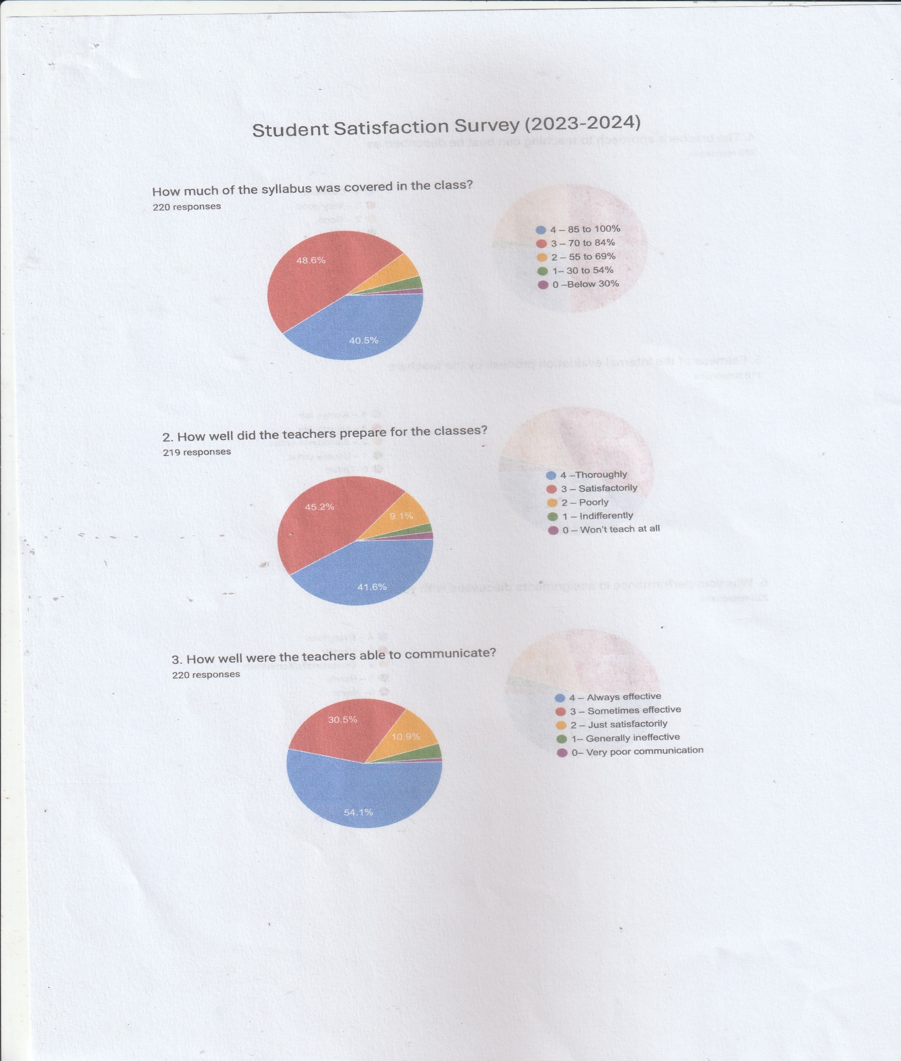
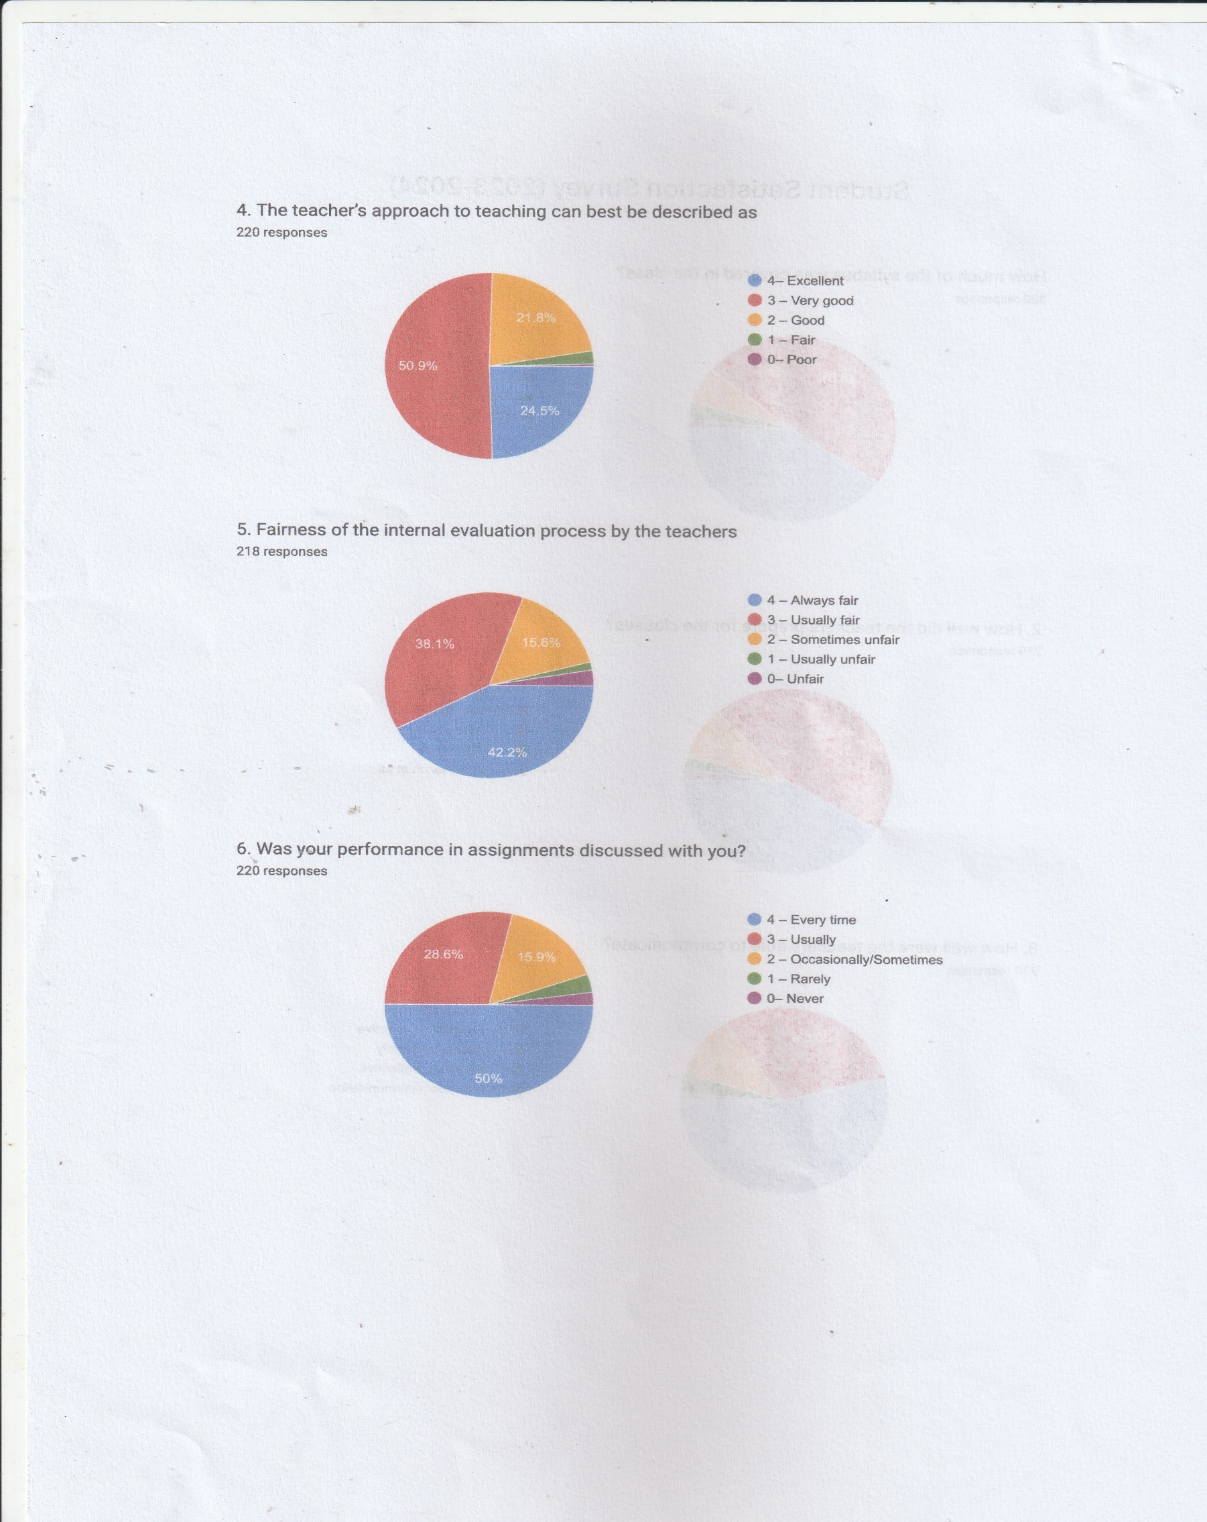
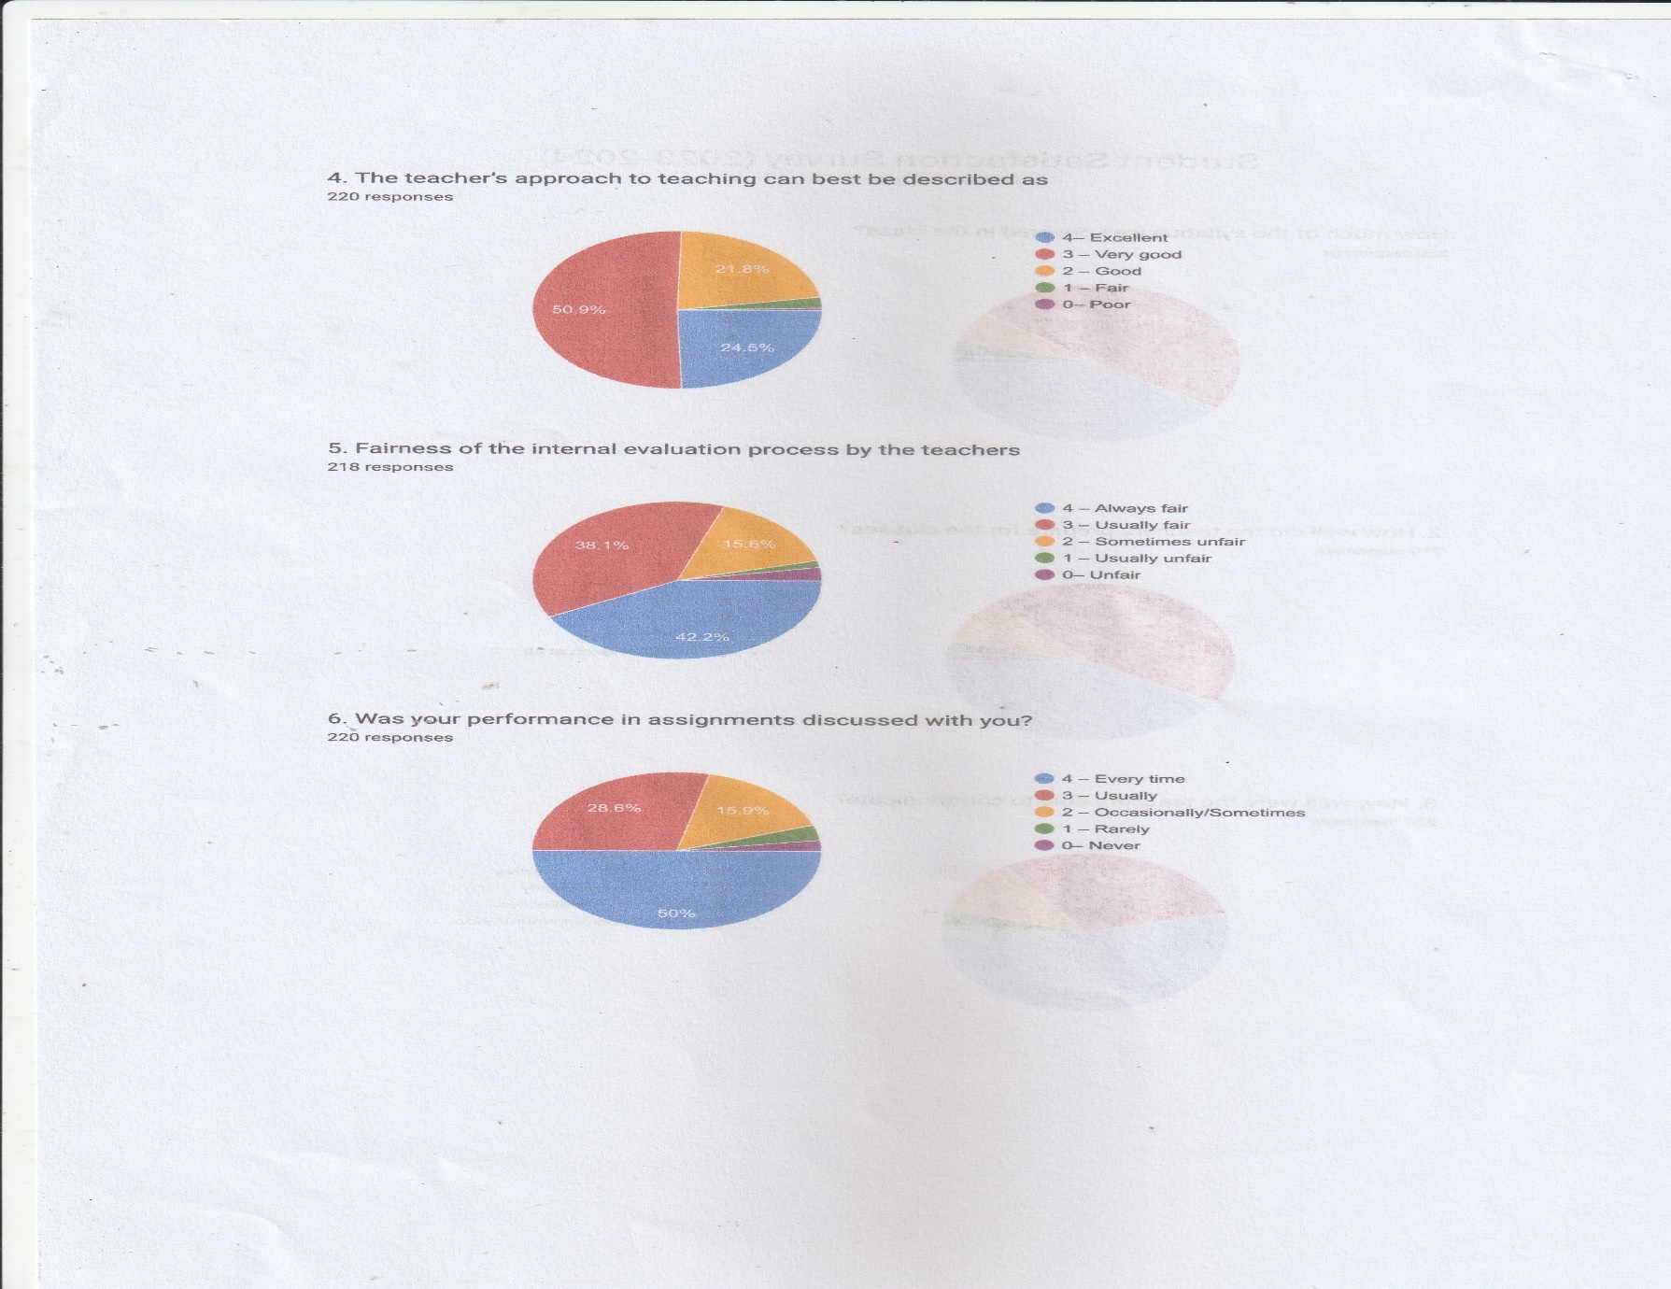
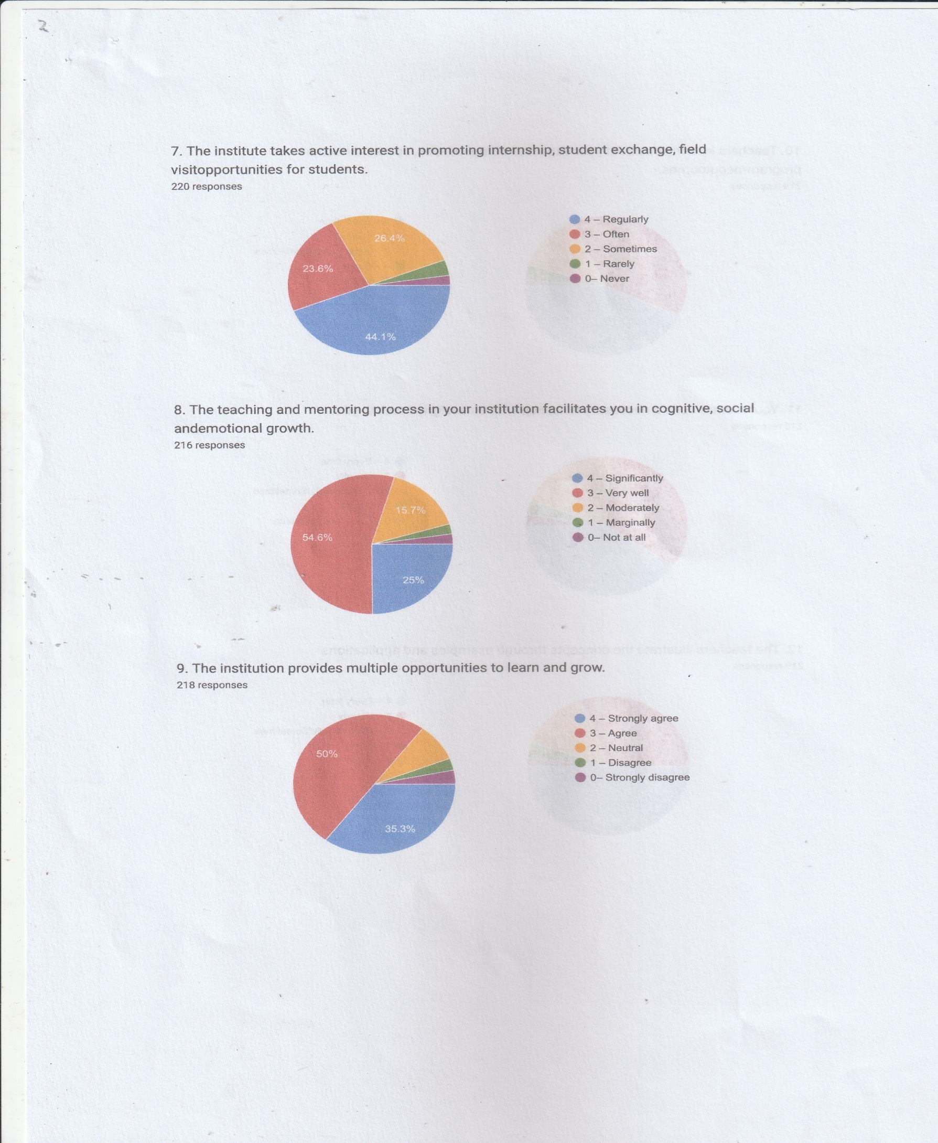
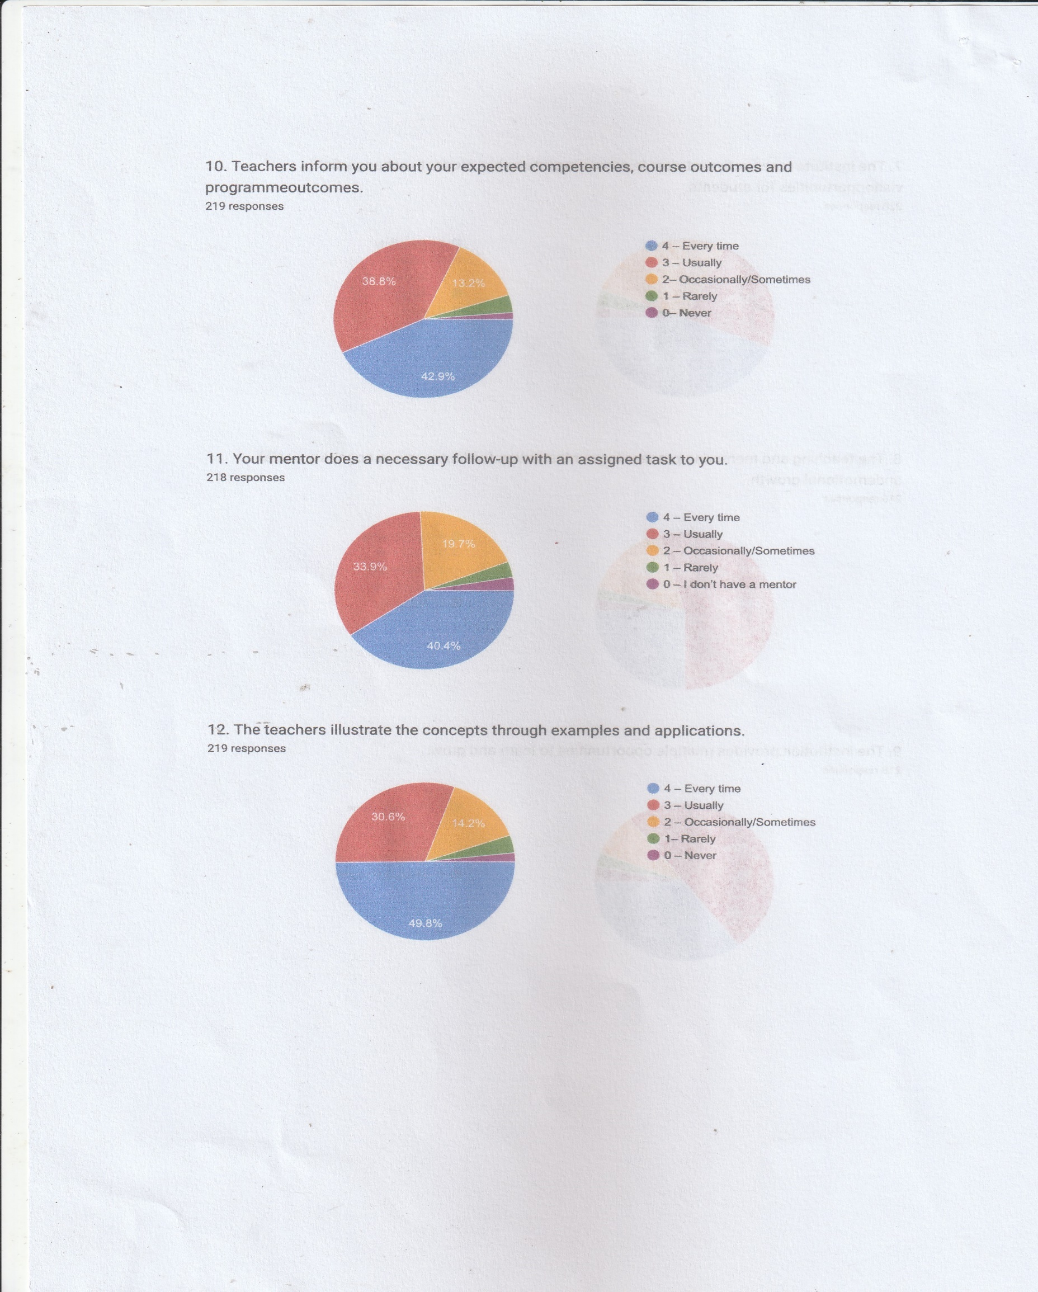
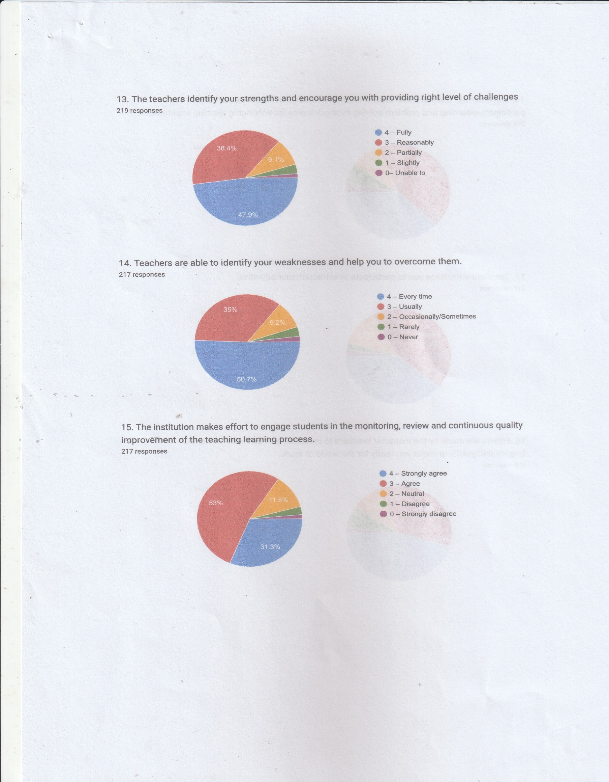
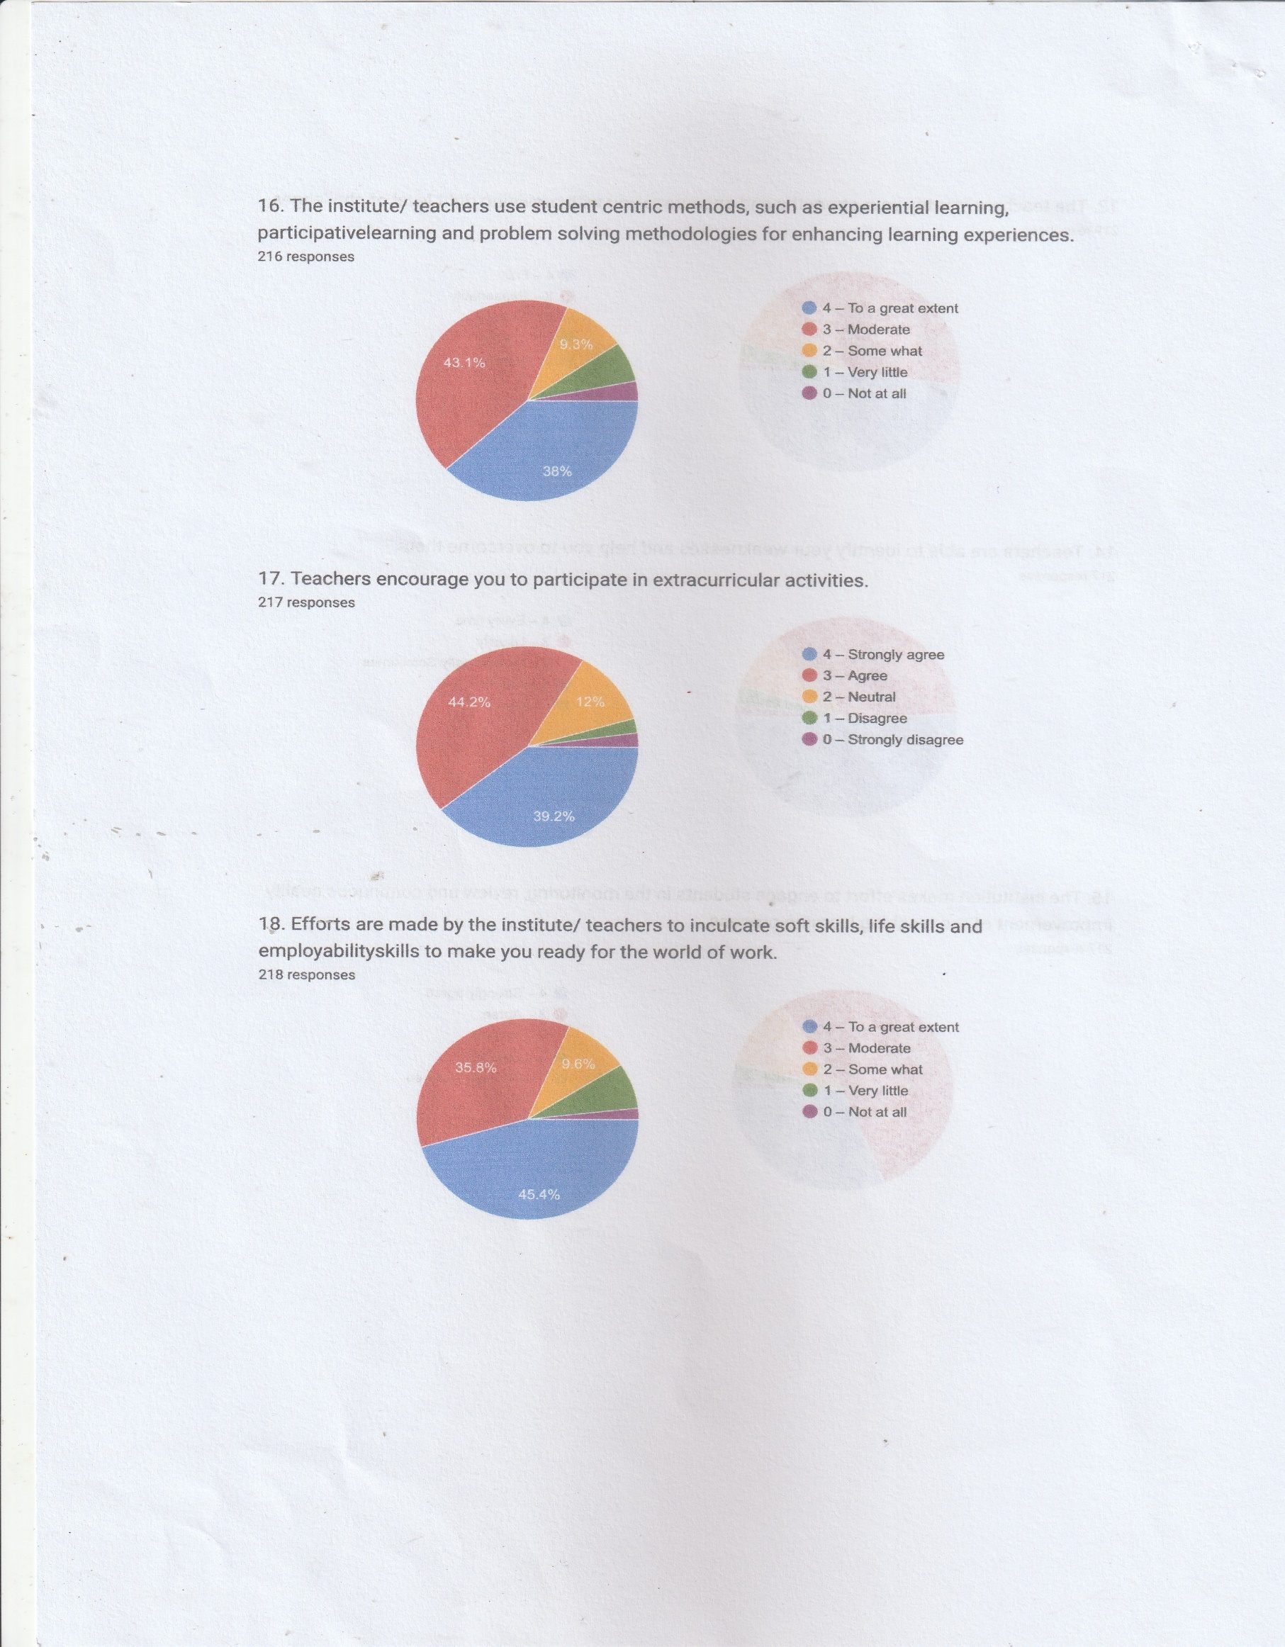
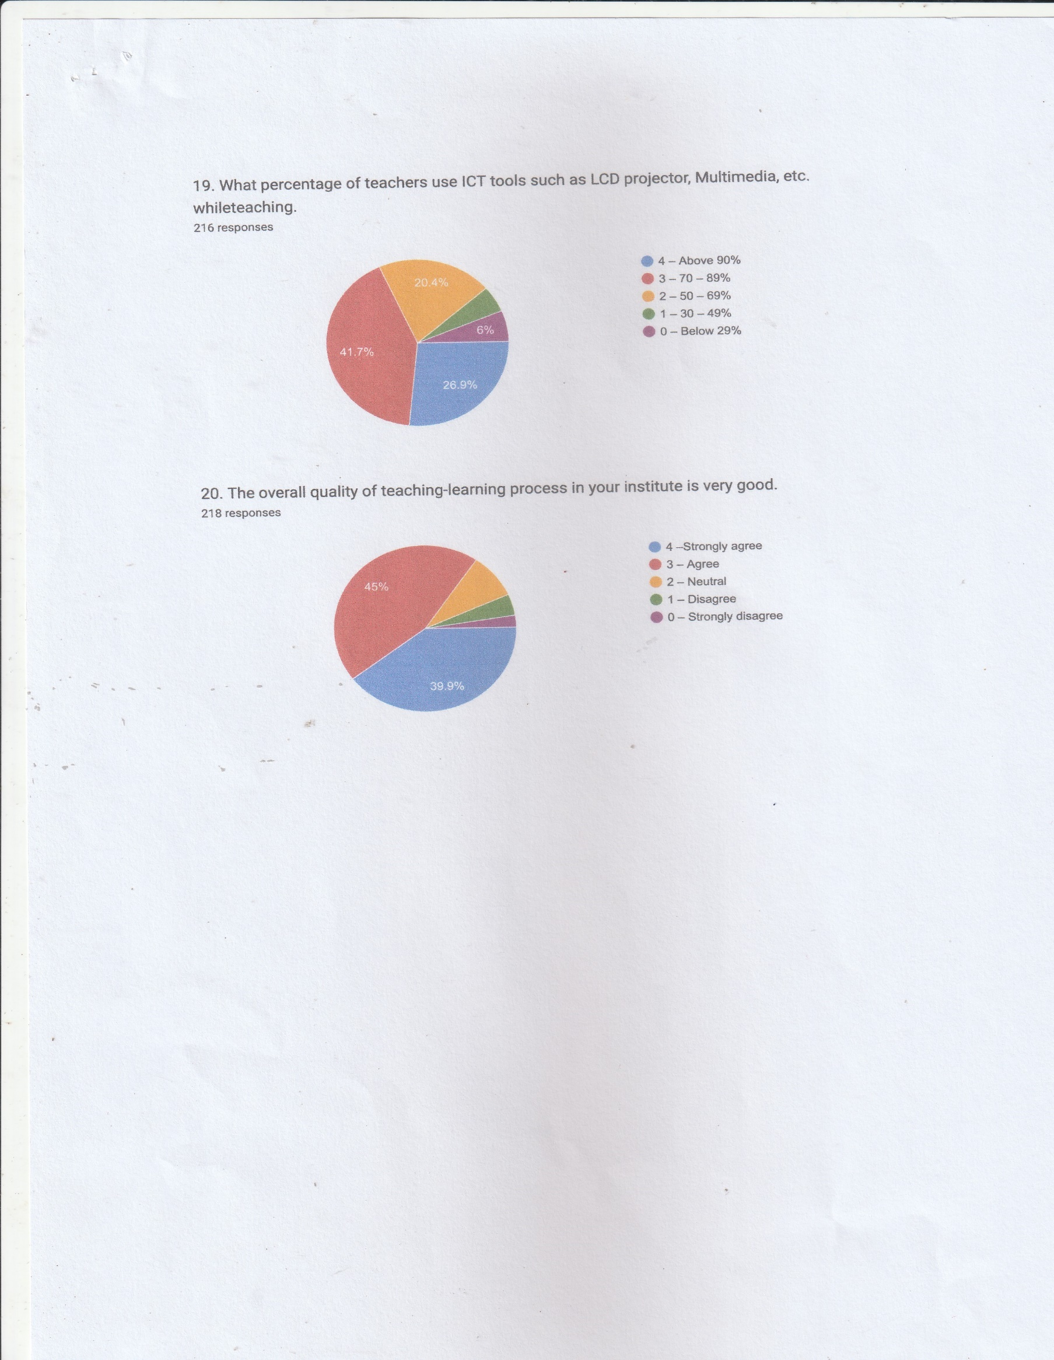
STUDENT SATISFACTION SURVEY
CONCLUSION:
The survey has been completed successfully. The IQAC reviewed and analysed the feedback received. When analysed it was found that some of the students suggested for the improvement in infrastructure especially the class rooms, digital class room, auditorium, play-ground, canteen and the library. Some students demanded for appointing new faculty members in some departments. The committee tried to initiate necessary measures for the improvement of the institution.

